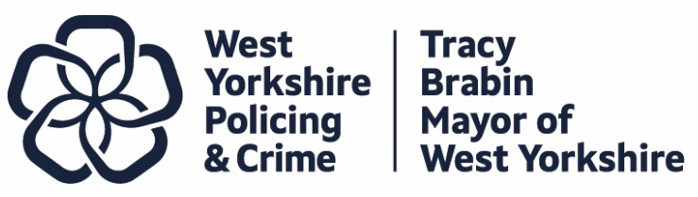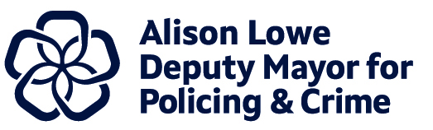
Item 7
Report to: |  | Police and Crime Panel
Date: |  | 7th November 2025
Subject: |  | Precept Consultation – Introductory Paper
Report of: | Alison Lowe – Deputy Mayor for Policing and Crime
Author: | Policing and Crime Team

- PURPOSE OF THE REPORT
  - The purpose of this report is to provide members of the Police and Crime Panel with an update on planning for the precept consultation.
  - This report will inform the Police and Crime Panel of the planning to date, ahead of the consultation period and ahead of the subsequent recommendation on the precept for next year.

- INFORMATION
  - The approach last year:
    - The public consultation on the 2025/26 Council Tax police precept ran with the online survey between 5th December 2024 and 22nd January 2025, with all our in-person consultation taking place in January 2025. Residents were invited to respond to the proposal of an equivalent £14 annual increase on Band D households, corresponding to 27 pence per week.
    - The consultation was promoted extensively online, including the use of targeted advertisements on social media platforms and through our partners and VCSE Sector to encourage under-represented groups to respond, including through the Combined Authority’s ‘Your Voice’ consultation platform. We also made the decision early in January to extend the online survey deadline from the original date of 17th of January to 22nd of January to attract a greater number of responses. This work was accompanied by a postal survey which reached 7,100 randomly selected West Yorkshire households.
    - By the close of both the online and postal surveys, 1,653 residents had responded and a further 502 individuals had taken part in our in-person consultation.

  - Proposed approach for this year:

    - As with previous precept consultations, we will continue to deliver an online survey and promote it through our own channels and via partners. We also have the option to promote the online survey via paid for social media advertisements to target underrepresented groups during the consultation period if required. The online consultation will be launched following the government’s announcement of the financial settlement and will include a binary question to assess residents’ support for the proposed tax increase. Both the online and in-person consultations will aim to capture the reasoning behind residents’ responses by including an optional open-ended question.
    - As in the previous year, all those taking part in the online and in person consultation will receive a clear and detailed cost breakdown outlining the charges applicable to their council tax band, along with an explanation of the rationale behind the increase in the police precept. Based on our learning from last year we will also be encouraging those who take part to review their council tax band, so they are able to provide an informed response.
    - Our in-person work led by the Consultation and Engagement team will again target high footfall locations with diverse communities across West Yorkshire. The team will again pilot the question content ahead of its launch to inform the context of the consultation, and the framing of the questions especially ahead of the in-person work.
    - Unlike in previous years, a postal survey will not be distributed to randomly selected addresses in West Yorkshire. The low response rate from last year’s postal survey has prompted a review of its cost-effectiveness, particularly in light of the rising expenses associated with postal distribution. Over the previous two consultation periods, more than 7,000 postal surveys yielded fewer than 400 responses. Given that the postal survey last year produced only a 1% change in the high level result, the decision has been made to discontinue the postal survey this year.
    - To minimise the risk of excluding individuals with limited digital access, the in-person consultation will be designed to engage with this group in addition to other underrepresented groups.
    - The objectives for the in-person consultation will include:
- Gathering feedback from a diverse group of residents, including under 35s and those who may be digitally excluded.
- To measure support for the police precept options for 26/27.
- Discuss the Serious Violence Strategy which is being Co-produced.
- Obtain feedback on policing services, which will inform our work.
    - The team has an estimated 6 weeks in which to undertake the consultation. Efforts will be made to keep the consultation open for as long as practicable to maximise engagement with our in-person opportunities running until 21 January 2026.
    - Some PCCs chose to launch their consultations ahead of the announcement of the Government settlement ahead of the consultation last year. However, feedback from our 2024 focus groups highlighted that respondents to both online and in person consultation should be able to respond based on actual rather than perceived impact which means the full financial context must be provided.
    - Of note, the previous focus group feedback also indicated that transparency is essential. Participants felt that if a specific precept increase is being proposed by the government and the Mayor was in agreement with this to be proposed for West Yorkshire, offering the option to show support for a lower amount would be of little value.

    - With this in mind, the proposal for this year is to continue with a short online survey which shows if there is support for the proposed precept increase and the in-person work will provide the detail around the impact, thoughts and feelings of the proposal.
- Conclusion
  - To conclude, the precept consultation for the 26/27 financial year aims to attract a diverse range of residents through the mixed method of online and in-person consultation and engagement.
  - The online survey will launch once the government has announced the financial settlement, utlising a binary question to gauge support for the proposed tax increase. The in-person work will take place across the first 3 weeks of January 2026. Both the online and in-person consultations will seek to understand the reasoning and rationale behind residents' answers by offering the option to answer an open question.
  - Like last year, residents will be offered a transparent cost breakdown of what costs they will incur based on their council tax band and reasoning as to why the police portion of council tax is being raised.
  - Building on last year’s success, the in-person consultation will again target high footfall locations with diverse residents to ensure that people who may be digitally excluded or prefer to engage in-person can take part in the consultation.
  - The Policing and Crime team and Deputy Mayor will endeavor to keep the consultation open as long as is feasible to ensure maximum engagement with residents.

