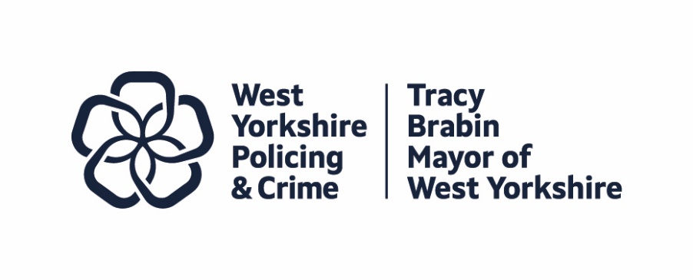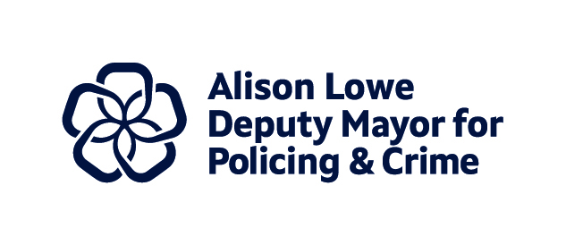
Item 7

Report to: |  | Police and Crime Panel
Date: |  | 8th November 2024
Subject: |  | Precept Consultation – Cover Paper
Report of: | Alison Lowe – Deputy Mayor for Policing and Crime
Author: | Policing and Crime Team

- PURPOSE OF THE REPORT
  - The purpose of this report is to provide members of the Police and Crime Panel with an update on planning for the precept consultation.
  - This report will inform the Police and Crime Panel of the planning to date, ahead of the consultation period and ahead of the subsequent recommendation on the precept for next year.

- INFORMATION
  - The Mayor is required under Schedule 5 of the Police Reform and Social Responsibility Act 2011 and associated regulations to notify the Police and Crime Panel of the proposed precept.
  - This report is being submitted ahead of the provisional Police Finance Settlement being announced. Consultation on the precept will take place following the announcement.
  - This report is also being written ahead of a meeting with Panel members on the 29th October 2024. This meeting has been set up following a previous commitment by the Mayor to discuss with Panel the content and format of future budget consultations, including looking at the approach taken in other PCC areas.
  - Therefore, the report in Appendix 1 seeks only to provide a brief update to Panel on planning to date.

- EQUALITY, DIVERSITY AND INCLUSION BENEFITS AND IMPLICATIONS
  - Equality impact assessment is an integral part of the precept and budget setting process. A full equality impact assessment has taken place.
  - Every effort will be made to make the consultation and engagement work as inclusive as possible within the available timeframe.

- IMPLICATIONS FOR YOUNG PEOPLE IN WEST YORKSHIRE
4.1 Many of the measures in the Police and Crime Plan directly affect children and young people in West Yorkshire, and the new cross cutting theme of children and young people will ensure that a Child First lens is applied across the Plan.

- FINANCIAL IMPLICATIONS
  - There are no financial implications to raise at this stage of the consultation development.

- LEGAL IMPLICATIONS
  - The Mayor has a statutory duty to set a balanced budget and calculate the Police Council Tax Requirement for the forthcoming financial year.

- EXTERNAL CONSULTATION
  - The consultation is the subject of the paper in Appendix 1, providing an update to Panel.
  - This consultation will inform the precept proposal.

- RECOMMENDATIONS
  - That the Police and Crime Panel note this report.

BACKGROUND PAPERS AND APPENDICES
Appendix 1 – Precept Consultation – Introductory Paper

CONTACT INFORMATION

Contact Officer: | Policing and Crime Team
E-mail: | consultation.pc@westyorks-ca.gov.uk

Report to: |  | Police and Crime Panel
Date: |  | 8th November 2024
Subject: |  | Precept Consultation – Introductory Paper
Report of: | Alison Lowe – Deputy Mayor for Policing and Crime
Author: | Policing and Crime Team

- PURPOSE OF THE REPORT
  - The purpose of this report is to provide members of the Police and Crime Panel with an update on planning for the precept consultation.
  - This report will inform the Police and Crime Panel of the planning to date, ahead of the consultation period and ahead of the subsequent recommendation on the precept for next year.

- INFORMATION
  - The approach last year:
    - The public consultation survey on the 2024/25 Council Tax police precept ran between 21 December 2023 and 17 January 2024. Residents were invited to respond to the proposal of a 5.55% increase, corresponding to 25 pence per week for a Band D property.
    - The consultation was promoted extensively online through the Mayor’s and Deputy Mayor’s X (Twitter) and Facebook accounts, through the Combined Authority’s ‘Your Voice’ consultation platform, and also circulated to our partners to help reach a wider audience. Two press releases were issued, and engagement also took place via an online survey accompanied by a postal survey reaching out to 7,000 randomly selected households in West Yorkshire. Engagement also took place through a significant number of focus events, aimed at reaching out to communities which have been under-represented in the past, as well as additional face to face work.
    - At the close of the survey, 2,063 residents had recorded their views on the precept proposal.
  - Proposed approach for this year:
    - As with previous precept consultations, we will continue to deliver an online survey and to promote it through our own channels and via partners.
    - In addition to our online survey, the Consultation and Engagement team are also looking to engage on the precept in person, building on their learning from the last consultation.
    - Early plans involve a mixture of key focus groups (building on the benefits of this approach, seen last year), and in person consultation in venues/sites which attract a high public footfall. The aim is to pilot the engagement to assess the interest in the consultation.
    - As with previous years we will also look to do a postal survey for a number of randomly selected addresses in West Yorkshire. By including a postal survey we ensure that members of the public who may not be digitally enabled can complete an online survey and will have the option to complete a hard copy version.
    - Although this will be sent to a random number of addresses, it will also be given as an option alongside the online survey.
    - The objectives for the consultation will include:
- Gathering feedback from a more diverse groups of residents, including under 35s.
- To measure support for the Police Precept options for 24/25.
- Discuss priorities including the Serious Violence Spotlight in the draft Police and Crime Plan.
- Obtain feedback on policing services, which will inform our work.
    - The team have an estimated 6 weeks in which to undertake the consultation.

