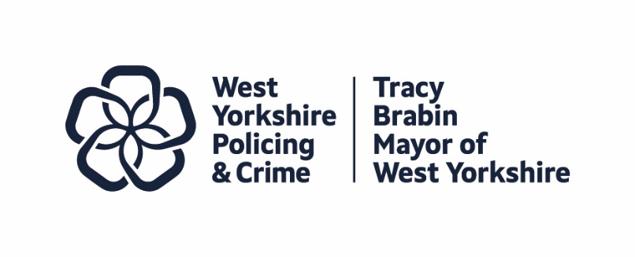
Item 5

Report to: | Police and Crime Panel
Date: | Friday 8th November 2024
Subject: | Annual Report 2023/24 Cover Report
Report of: | Tracy Brabin, Mayor of West Yorkshire
Author(s): | Wendy Stevens, Research and Performance Manager  Anna Scaife, Research and Performance Officer

- PURPOSE OF THE REPORT

  - To provide members of the Police and Crime Panel with a draft of the Policing and Crime 2023/24 Annual Report for comment and feedback before formal publication.

- INFORMATION

  - The Police Reform and Social Responsibility Act 2011 states that policing bodies (in this case the Mayor) must produce an Annual Report that sets out the exercise of the body’s functions in each financial year.
  - This annual report covers the financial year 2023/24, and describes key activity undertaken by the Mayor and Deputy Mayor for Policing and Crime (DMPC), the police and partners, towards meeting the outcomes and priorities set out in the Police and Crime Plan 21-24.
  - This is a draft version of the report. A finalised version will be published in due course. In the meantime, this draft provides an opportunity for Police and Crime Panel members and other partners to comment on the content.
  - This report also includes an assurance statement explaining how the Mayor and West Yorkshire Police (WYP) have considered the Strategic Policing Requirement (SPR), and how the SPR has influenced activities and the force’s objectives for the year.

- EQUALITY, DIVERSITY AND INCLUSION BENEFITS AND IMPLICATIONS

  - Under the Public Sector Equality Duty (PSED) in the Equality Act 2010, Mayors/PCCs are required to have due regard to the need to eliminate conduct prohibited by the Act (such as discrimination, harassment and victimisation), advance equality of opportunity and foster good relationships between different people.
  - This Annual Report details the work of the Mayor and Combined Authority under the Police and Crime Plan which reflects our commitment toward meeting these aims.
- IMPLICATIONS FOR YOUNG PEOPLE IN WEST YORKSHIRE

4.1 Many of the priorities in the Police and Crime Plan directly affect young people in West Yorkshire, and this is highlighted in the document.
- FINANCIAL IMPLICATIONS

  - None

- LEGAL IMPLICATIONS

  - The publishing of an Annual Report is a legal requirement under the Police Reform and Social Responsibility Act 2011. The Act states that policing bodies (in this case the Mayor) must produce an Annual Report that sets out the exercise of the body’s functions in each financial year, and the progress which has been made in meeting the objectives set out in the Police and Crime Plan.

- EXTERNAL CONSULTATION

  - The Police and Crime Plan was subject to extensive external consultation and the measures which form the main part of this report resulted from that consultation.
  - Over the life of the Plan there have also been surveys to assist in the various strategies and other work, these have been reported to Panel in previous papers.
- RECOMMENDATIONS

  - That the Police and Crime Panel note this report and consider providing feedback.

BACKGROUND PAPERS AND APPENDICES

Draft Annual Report 2023/24

CONTACT INFORMATION

Contact Officer: | Anna Scaife
E-mail: | Anna.scaife@westyorks-ca.gov.uk

