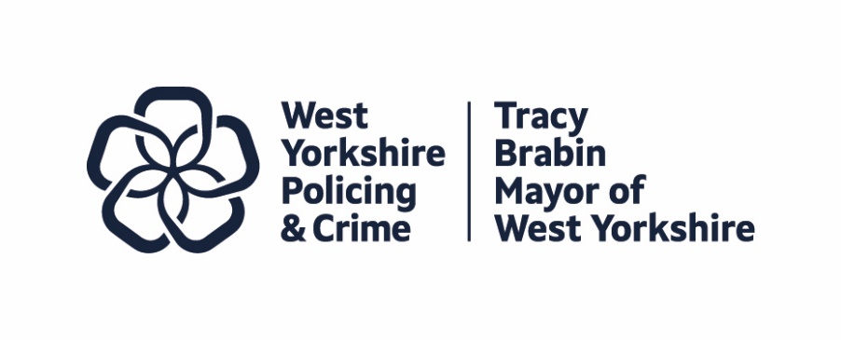
Item 7
Report to: | Police and Crime Panel
Date: | 11th July 2025
Subject: | Complaints Report
Report of: | Alison Lowe, Deputy Mayor of West Yorkshire for Policing and Crime
Author: | Tiffany Dustain, Casework and Reviews Manager

- PURPOSE OF THE REPORT

  - To provide an overview of complaints and conduct matters dealt with by the Policing and Crime Team.
  - To provide an overview of the work by the Professional Standards Department in West Yorkshire Police (Appendix A)

- INFORMATION

  - Complaint Reviews
    - From 1 February 2020, Police and Crime Commissioners (PCCs) and the Independent Office for Police Conduct (IOPC) became responsible for carrying out reviews of complaints recorded and handled under Schedule 3 of the Police Reform Act 2002. Criteria within the Policing and Crime Act 2017 set out which reviews are undertaken by the IOPC; PCCs became responsible for the remainder. From 10 May 2021 this responsibility passed to the West Yorkshire Mayor. The responsibility for reviews is delegated through to the Casework staff in the Policing and Crime Team.
    - All three members of the Casework Team now undertake reviews, and due to increases in the volume of reviews requested, both Casework and Reviews Officers are now completing a larger share of reviews. This ensures cover during absences and provides resilience for a small number of cases where there has been previous involvement by another member of the Team.
    - The following table shows data for the last four full years of reviews, to enable trend information to be seen.

Category | 2024-25 | 2023 - 24 | 2022 - 23 | 2021 - 22
Number of review requests received | 294 | 230 | 240 | 198
Number of reviews completed, including those carried forward from the previous year | 234 | 203 | 199 | 157
Number of reviews carried forward to the next year/quarter | 20 | 8 | 14 | 7
Number of reviews of complaints completed of complaints handled ‘otherwise than by investigation’ (OTBI) | 234 | 198 | 193 | 152
Number of reviews of complaints completed of complaints handled by investigation (INV) | 0 | 5 | 6 | 5
Number and proportion of reviews upheld | 46  19.7% | 31  15.3% | 42  21.1% | 32  20.4%
Number of OTBI reviews upheld | 46 | 31 | 40 | 29
Number of INV reviews upheld | 0 | 0 | 2 | 3
Number of upheld reviews where the recommended course of action was investigation by IOPC | 0 | 0 | 0 | 0
Number of upheld reviews where the recommended course of action was investigation by West Yorkshire Police | 0 | 5 | 16 | 21
Number of upheld reviews where the recommended course of action was a remedy under Section 28ZA of Schedule 3 of the Police Reform Act 2002* | 14 | 15 | 16 | 8
Number of upheld reviews where the recommended course of action was more handling otherwise than by investigation. | 19 | 3 | 0 | 0
Number of upheld reviews where there was no recommended course of action | 13 | 8 | 10 | 3
Number of late requests received | 21 | 21 | 18 | 11
Number of late requests received which were accepted | 7 | 10 | 9 | 4
Number of late requests received which were declined | 14 | 11 | 9 | 7
Number of review requests received which were invalid, which includes the late requests which were declined | 47 | 34 | 34 | 38
Number of review requests received made to the wrong review body | 24 | 9 | 9 | 22
Number of review requests received where the complainant did not have a right of review | 6 | 12 | 11 | 7
Number of other invalid review requests received | 3 | 2 | 5 | 2
Average number of working days to accept a review request, counted from the date received | 1.56 | 0.5 | 0.77 | 0.93
Average number of working days to complete a review, counted from the date accepted | 17.03 | 10.6 | 13.5 | 12.97

* One of the options available is to recommend an action to remedy the complainant's dissatisfaction. Paragraph 28Za of Schedule 3 of the Police Reform Act 2002 is the legislation which allows this.

    - The above information along with regular reports from the Professional Standards Directorate is also scrutinised by the Mayor and Deputy Mayor for Policing and Crime as part of holding the Chief Constable to account for the Force handling of complaints.
    - 2024/25 saw an upward trend in the number of reviews requested with an increase of approximately 27.8%. The number of complaints received by West Yorkshire Police’s Professional Standards Directorate in 2024/25 also rose by nearly 10.9%, which accounts for some, but not all, of the increase. Requests for reviews from complainants continue to be closely monitored for any emerging trends in order to assist in providing further insight into the increase in volume.
    - The purpose of a review, as set out in the legislation, is to determine whether the outcome of the complaint was reasonable and proportionate. It is not to reinvestigate someone’s complaint. West Yorkshire Police provides the Reviewer with access to its folder for the complaint, where all information collected by the complaint handler in the course of their enquiries into the complaint is stored. Reviewers are also given access to Niche (WY Police’s crime recording system) and the Force’s Body Worn Video system, having had appropriate training.
    - While undertaking a review, reviewers answer the following questions, which are specified in the IOPC’s Statutory Guidance:
- Whether the complaint was fully understood, and all allegations or concerns addressed;
- Whether reasonable lines of enquiries were undertaken to be able to provide a reasonable and proportionate outcome;
- Whether due regard was given to relevant guidance;
- Where any aspects of the complaint were not addressed, or any lines of enquiry were not pursued, whether there were sound reasons given for this;
- Whether information or evidence was weighed appropriately and fairly;
- Whether the findings or determinations reached logically follow from the information or evidence obtained;
- Whether enough information was given to the complainant to address the complaint and support the outcome (added recently following attendance at IOPC workshop on reviews).
    - If any actions are identified, the reviewer will consider the following points, which are again in the IOPC’s Statutory Guidance:
- Whether due regard was given to the relevant legal tests and guidance;
- Whether the complaint handler attempted to understand the outcome sought by the complainant and gave that due consideration;
- Whether the proposed actions have sought to remedy the issues raised, so far as is reasonably possible;
- Whether the proposed actions are reasonable and proportionate, considering all the circumstances;
- Whether actions have been proposed or taken in respect of any learning or other issues identified through the handling of the matter.

    - If a complaint is upheld, the Reviewer can make a recommendation to the Force to either:
- Refer it to the IOPC;
- Investigate the complaint (if it was dealt with ‘otherwise than by an investigation’); or
- Undertake specific actions to remedy the complainant’s dissatisfaction.

  - Complaints against the Chief Constable
    - The Mayor is responsible for dealing with complaints or conduct matters against the Chief Constable under the Police Reform Act 2002. From 1 February 2020 complaints received about the Chief Constable were handled in line with the legislative changes brought in by the Policing and Crime Act 2017. Details of the complaints recorded against the Chief Constable are published on the Combined Authority’s website.
    - The Policing and Crime Act 2017 no longer requires complaints about the Chief Constable which are really about a matter that is delegated to others within the Force to be recorded. The legislation recognised that such complaints should be passed to the Force to resolve, and the complainant advised of the action taken. Prior to 1 February 2020 such complaints would have had to have been recorded and resolved on-the-spot by providing an explanation that the responsibility had been delegated.
    - In 2024/25 6 public complaints about the Chief Constable were received and not recorded. 4 complaints were judged to not be complaints about the Chief Constable because they were about delegated matters, or the Chief Constable had no personal involvement in the matter being complained about. 1 complaint was deemed not eligible to complain and 1 complaint was withdrawn
    - No conduct matters have been recorded against the Chief Constable during 2024/25.

- EQUALITY, DIVERSITY AND INCLUSION BENEFITS AND IMPLICATIONS

  - The West Yorkshire Professional Standards department paper looks explicitly at the implications of equality, diversity and inclusion with regard to complaints and complaint handling in West Yorkshire Police.
  - This introspective work will provide a platform to ensure that people from an ethnic minority background are treated equally in this area.
  - Significant analytical work has recently been undertaken by the West Yorkshire Professional Standards department, to further explore areas of disproportionality within misconduct and complaint data.
- IMPLICATIONS FOR YOUNG PEOPLE IN WEST YORKSHIRE

  - There is no direct implication for young people in West Yorkshire, although any improvements will also benefit those that come into contact with the process for any reason.

- FINANCIAL IMPLICATIONS

  - Both the Policing and Crime Team and West Yorkshire Police invest resources into this area. Any changes have a direct impact on the numbers required to cover this area of business.

- LEGAL IMPLICATIONS

  - As stated in the report, all work in this area is completed to legal requirements and this is checked on a regular basis

- EXTERNAL CONSULTATION

  - The complaints procedures are designed to be open and transparent with the public able to attend and watch various procedures.
  - This information is also published on the Combined Authority’s website to comply with The Elected Local Policing Bodies (Specified Information) (Amendment) Order 2021.

- RECOMMENDATIONS

  - That the complaints and conduct monitoring information is noted by the Panel.
  - That the Professional Standards paper at Appendix A is noted by the Panel.

BACKGROUND PAPERS AND APPENDICES

Appendix A – Professional Standards Department Report
Appendix B - Police Complaints Information Bulletin: West Yorkshire

CONTACT INFORMATION

Contact Officer: | Tiffany Dustain and Wendy Stevens
E-mail: | policingandcrime@westyorks-ca.gov.uk

