**Item 7**

|  |  |  |  |
| --- | --- | --- | --- |
|  | | | |
| **Report to:** | | Police and Crime Panel | |
| **Date:** | | 13th September 2024 | |
| **Subject:** | | Police and Crime plan Policing Landscape | |
| **Report of:** | Alison Lowe – Deputy Mayor for Policing and Crime | |
| **Author:** | Policing and Crime Team | |

1. **PURPOSE OF THE REPORT**
   1. The purpose of this report is to provide members of the Police and Crime Panel with an overview of the current national policy areas and statutory guidance which will affect the new Police and Crime Plan.
   2. This report will inform the Police and Crime Panel of the current thinking behind the new Police and Crime Plan.
2. **INFORMATION**
   1. The Police Reform and Social Responsibility Act 2011 sets out the requirement for the Mayor to issue a Police and Crime Plan as soon as practicable after taking office and, in any case, before the end of the financial year (31st March) in which the Mayor is elected.
   2. The Plan is important as it sets out and communicates the policing and crime priorities, as the Mayor sees them, to West Yorkshire Police; the public; partner agencies; the Police and Crime Panel; the Home Secretary; and others with an interest in how West Yorkshire is policed and kept safe.
   3. The Policing Protocol Order 2023 states that ‘The public accountability for the delivery and performance of the police service is placed into the hands of the PCC[1] [Police and Crime Commissioner] on behalf of their electorate. The PCC draws on their mandate [i.e. their pledges and manifesto] to set and shape the strategic objectives [i.e. construct a Police and Crime Plan] for their force area in consultation with the Chief Constable.’
   4. Since the Mayor was elected in May 2024, the Policing and Crime team have been working to translate the pledges and commitments from the Mayor’s Manifesto into draft priorities and cross cutting themes for the new Police and Crime Plan.
   5. Before a Police and Crime Plan is issued under section 5 or 6 of the Police Reform and Social Responsibility Act 2011, the views of the people in that police area, and the views of victims of crime in that area, should be obtained on that Plan.
   6. The Policing and Crime team are currently undertaking a widescale consultation based on the following draft Plan on a Page:
   7. 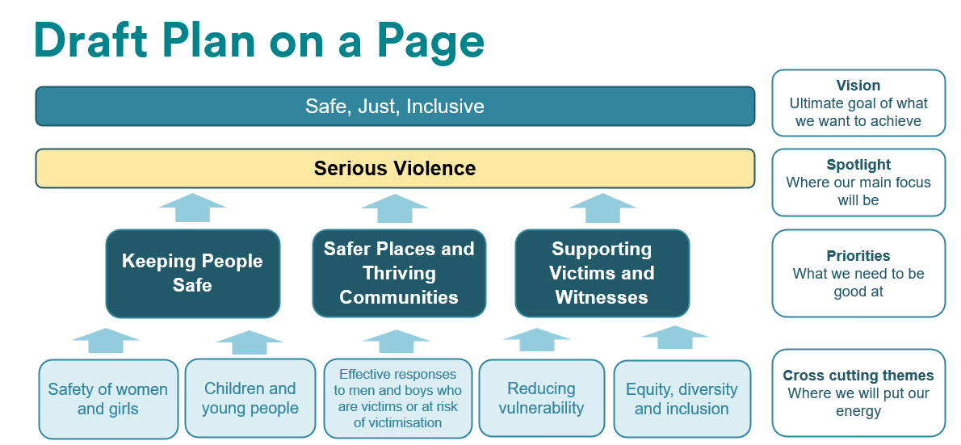.

2.8 For more information on the Police and Crime Plan consultation, please visit <https://www.westyorks-ca.gov.uk/policing-and-crime/tell-tracy-about-policing-and-crime/>

2.9. To have your say, you can fill in the consultation survey by visiting the link above.

2.10. The Policing Protocol 2023 also states that PCCs should take into account national policy when delivering their Police and Crime Plans.

2.11. The report in Appendix 1 looks at the changes in national and local policy since the last Police and Crime Plan and gives the Police and Crime Panel an overview of the current policing landscape in which the Police and Crime Plan is situated - in light of the above statutory requirement.

1. **EQUALITY, DIVERSITY AND INCLUSION BENEFITS AND IMPLICATIONS**
   1. The new Police and Crime Plan will be subject to an Equality Impact Assessment – this is being written as the Plan progresses to ensure that every element of the Plan has the benefit of its overview.
2. **IMPLICATIONS FOR YOUNG PEOPLE IN WEST YORKSHIRE**

4.1 Many of the measures in the Police and Crime Plan directly affect children and young people in West Yorkshire, and the new cross cutting theme of children and young people will ensure that a Child First[2] lens is applied across the Plan.

1. **FINANCIAL IMPLICATIONS**
   1. None.
2. **LEGAL IMPLICATIONS**
   1. The Police Reform and Social Responsibility Act 2011 sets out the requirement for the Mayor to issue a Police and Crime Plan as soon as practicable after taking office and, in any case, before the end of the financial year (31st March) in which the Mayor is elected.
   2. The Police and Crime Plan should determine, direct, and communicate the Mayor’s priorities for their local area during their period in office. The Police and Crime Plan will update the Police and Crime Panel on these priorities and will provide:

* An update on the Mayor’s police and crime objectives for the area,
* An update on policing which the Chief Constable provides,
* One of the means by which the Chief Constable reports to the Mayor on the provision of policing, and,
* One of the means by which the Chief Constable’s performance in providing policing is measured.

1. **EXTERNAL CONSULTATION** 
   1. The Police and Crime Plan is currently the subject of an extensive external consultation with in-person and online opportunities for individuals, community groups and partners to engage. The consultation has defined objectives around inclusivity and accessibility, and progress updates will be shared with the Panel.
   2. This consultation will form the ‘Voice of West Yorkshire’ which will accompany the plan and provide the public’s view on police and crime priorities.
2. **RECOMMENDATIONS**
   1. That the Police and Crime Panel note this report.

**BACKGROUND PAPERS AND APPENDICES**

**Appendix 1 – Policing Landscape for the new Police and Crime Plan**

**CONTACT INFORMATION**

|  |  |
| --- | --- |
| Contact Officer: | Wendy Stevens |
| E-mail: | [Wendy.stevens@westyorks-ca.gov.uk](mailto:Wendy.stevens@westyorks-ca.gov.uk) |

1. The Mayor has PCC responsibilities in West Yorkshire
2. [Child First Approach - West Yorkshire Combined Authority (westyorks-ca.gov.uk)](https://www.westyorks-ca.gov.uk/policing-and-crime/west-yorkshire-violence-reduction-partnership/child-first-approach/)