**Item 5**

|  |  |
| --- | --- |
|  | |
| **Report to:** | Police and Crime Panel |
| **Date:** | 13th December 2024 |
| **Subject:** | Performance Monitoring Report |
| **Report of:** | Tracy Brabin – Mayor of West Yorkshire |
| **Author:** | Wendy Stevens, Research & Performance Manager. |

1. **PURPOSE OF THE REPORT**
   1. The attached performance report aims to set out a summary of the performance information scrutinised, and the issues raised in the Performance Scrutiny meeting, in relation to the delivery measures contained in the Police and Crime Plan and some wider environmental scanning.
   2. The report contains an overview of all the measures from the Police and Crime Plan along with sections summarising progress made in the last quarter.
   3. The data included in the report comes from several sources of national and local information, including police performance reporting, data from the Mayor’s Policing and Crime Team, Her Majesty’s Inspectorate of Constabulary and Fire & Rescue Services (HMICFRS) inspection reports, the WYP user satisfaction survey, and Ministry of Justice and Local Criminal Justice Board (LCJB) data.
   4. Data contained within the report covers the 12 months to September 2024 unless otherwise stated. Please note that data sources were correct and up to date at the time the report was produced. The data may have changed or moved on slightly since this report was published as crime and community safety is a continually developing area. It is important to note that this is not an exhaustive account of delivery activity in West Yorkshire, but rather an overview to present any issues and provide reassurance.
2. **INFORMATION**
   1. On the 12th November 2024 the Performance Scrutiny meeting was held with the Chief Constable of West Yorkshire Police. This meeting was given over to discuss the performance measures for the new Police and Crime Plan, although we did discuss some of the priority issues also.
   2. Managing the pressures placed on the police and our partners continues to be a challenge. We are committed to ensuring that West Yorkshire Police have the resources they need and are working efficiently with partners to deliver the service that communities need and deserve.
   3. We are also committed to ensuring that the Criminal Justice System works effectively and continue to drive this through the Local Criminal Justice Board.

2.4 The full report on all the measures is attached as Appendix 1.

1. **EQUALITY, DIVERSITY AND INCLUSION BENEFITS AND IMPLICATIONS**
   1. Equality, Diversity and Inclusion are key parts of this report, particularly evidenced by the key measure of ‘having a police service which is more representative of the people it serves’ and the section of the report on Hate Crime.
   2. The Police and Crime Plan (from which this report draws its measures) was subject to an Equality Impact Assessment.
2. **IMPLICATIONS FOR YOUNG PEOPLE IN WEST YORKSHIRE**

4.1 Many of the measures in the Police and Crime Plan directly affect young people in West Yorkshire and, where possible, the metrics are broken down to show this effect.

1. **FINANCIAL IMPLICATIONS**
   1. None.
2. **LEGAL IMPLICATIONS**
   1. The Police Reform and Social Responsibility Act 2011 and the Policing Protocol Order 2023 sets out the requirement for the Mayor to issue a Police and Crime Plan as soon as practicable after taking office and, in any case, before the end of the financial year (31st March) in which the Mayor is elected.
   2. The Police and Crime Plan should determine, direct, and communicate the Mayor’s priorities for their local area during their period in office. This report updates the Police and Crime Panel on these priorities and provides:

* An update on the Mayor’s police and crime objectives for the area,
* An update on policing which the Chief Constable provides,
* One of the means by which the Chief Constable reports to the Mayor on the provision of policing, and,
* One of the means by which the Chief Constable’s performance in providing policing is measured.

1. **EXTERNAL CONSULTATION** 
   1. The Police and Crime Plan was subject to extensive external consultation and the measures that form the main part of this report resulted from that consultation.
2. **RECOMMENDATIONS**
   1. That the Police and Crime Panel note this report.

**BACKGROUND PAPERS AND APPENDICES**

**Appendix 1 – Performance Monitoring Report**

**CONTACT INFORMATION**

|  |  |
| --- | --- |
| Contact Officer: | Wendy Stevens |
| E-mail: | [Wendy.stevens@westyorks-ca.gov.uk](mailto:Wendy.stevens@westyorks-ca.gov.uk) |

**Appendix 1.**

PERFORMANCE MONITORING REPORT

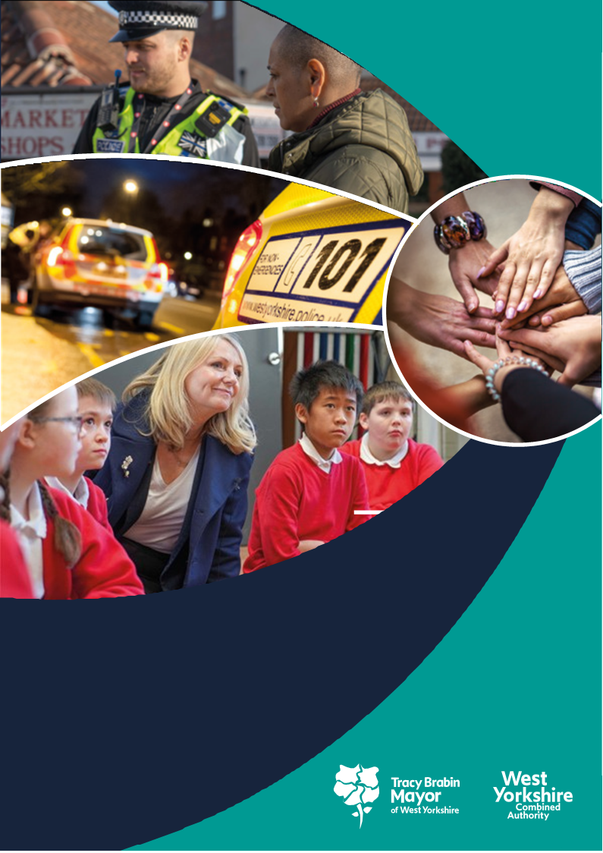

**West Yorkshire:**

**Safe. Just. Inclusive**

**Police and Crime Plan 2021-2024**

**1. Supporting Victims and Witnesses and Improving Criminal Justice Outcomes**



# 

**1.1 Victim Satisfaction**

1.1.1 The latest victim satisfaction rate stands at 72.8% for the 12 months to September 2024. The latest position 1.2% higher than 12 months ago.



1.1.2 Performance levels range from around 72% at Bradford, to 79% at Calderdale. The increases are still being seen at Wakefield, but Bradford is still below the same time last year. The district satisfaction score only looks at crimes dealt with by the district. Those telephone investigations dealt with via the Force Crime Management Unit (FCMU) are not included in the district ratings but are included in the overall West Yorkshire rating.

1.1.3 Victims of Arson and Criminal Damage and Hate have the lowest levels of satisfaction at less than 65% whereas Safety and Welfare callers and Domestic Abuse victims are the most satisfied, with levels over 80%. Increases in overall satisfaction have been seen for ASB, up 3.4% to 72.5%, and Violence against the person, up 4.4% to 70.0%.

1.1.4 There is now a significant difference between overall satisfaction of White victims (74.8%) and for victims and callers from all other ethnic groups combined (68.2%) leading to a satisfaction gap of 6.6%, compared to 5.9% a year ago. The gap varies from 1.7% at Calderdale to 8.1% at Kirklees and stands at 7.6% at FCMU.

## 1.2 Maintain high levels of calls answered on target.

1.2.1 In the latest 12 months to September 2024 the number of total contacts into West Yorkshire Police have fallen by 11.6% (188k fewer contacts). During the same period 999s have fallen by 6.2% (32k fewer calls), 101 calls have fallen by 14.1% (104k fewer calls), whilst other calls have increased by 2.6% (1,816 more calls) and online contacts have fallen by 11.6% (54k fewer contacts). The very latest quarter is reporting a smaller downturn in demand with overall contacts falling by 5.2%.

1.2.2 The Force continues report excellent call handling times for Emergency callers with 999 calls answered on average in just 6.1 seconds over the past quarter which is the 6th fastest in the country (using National performance data which is impacted by BT transfer times).

1.2.3 Over the last 12-month period the Force is ranked 3rd fastest nationally. In the latest quarter the Force answered just 0.4% of 999s in over 60 seconds (5th best nationally) and answered 89.6% of 999s in under 10 seconds (12th best nationally).

1.2.4 The below graphs show the current 101 rates with a peak in June 2023, when the abandonment rate was also high. The second chart looks at the average answer time – from this we can see that June and September are the pinch points in previous years, but this year these have stayed at normal levels.



1.2.4 For information – The above is from Police.uk who produce statistics on 999 answering times, but these also include transfer times from BT, which can be 4-6 seconds and can vary across police forces. The comparison data with other forces is available [here](https://www.police.uk/pu/your-area/west-yorkshire-police/performance/999-performance-data/?tc=BDT_BW).

## 1.3 Improve Outcomes

**1.3.1 Rape and Serious Sexual Offences**



1.3.2 The above table shows the position in Sept 2024 in comparison to the same time last year. The numbers of rape offences are 329 offences higher than the same time last year, and the outcome rate has increased by 0.9% which means that 63 more victims have received a positive outcome.

1.3.3 The most recent data that is available nationally is up to Sept 2024. This data compares forces by looking at crimes per 100,000 population. Previously other areas were not close in number to West Yorkshire, but now we see large increases in some areas. Although WY still has the highest numbers, other areas are now much closer (table below sorted by difference to baseline). Most recent inspection show West Mids. has a good rating and Greater Manchester has adequate for crime recording compared to the outstanding for WYP



**Serious Sexual Offences**



1.3.4 Serious Sexual Offence numbers have increased by 2.9% in comparison with the same time last year, and the positive outcome rate has risen by 0.3% with 47 more victims receiving a positive outcome.



1.3.5 Nationally the Serious Sexual Offence category is not reported on, as this category includes the rape offences above, but the below looks at Sexual Assault and Other Sexual offences categories. In a similar manner to the above Rape Offences (with the baseline Jan – Dec 2019), the table below gives an indication of the current position.



Every force has seen an increase in the reporting of these offences and West Yorkshire no longer has the highest figures with Greater Manchester recording more offences per 100,000 population in the last 12 months.

**1.3.6 Domestic Abuse Crime Outcomes**



1.3.7 The above looks at the data for the last 12 months compared to the previous 12 months. The number of Domestic Abuse Crimes has fallen by over 8000 in the last 12 months which is a 14.4% decrease. This rate of decrease is slowing in comparison to previous quarters. The current outcome rate has decrease by 0.5% also.

1.3.8 As requested the below data looks at domestic crimes per 1,000 population across West Yorkshire.



All areas have seen a decrease in domestic crimes and, in most areas, this is similar to the average across West Yorkshire, although the decrease in Calderdale is higher, but this could be due to the lower numbers

**1.4 Increase proportion of crimes with victim initial needs assessment**

1.4.1 The Initial Victim Needs Assessment (IVNA) is part of the Victims Code of Practice and is intended to:

1. Determine if the victim needs support.

2. Establish the type of support needed.

3. Assess whether the victim is vulnerable or intimidated.

4. Consider whether the victim is entitled to enhanced rights.

1.4.2 The guidance from the College of Policing shows that obtaining this at initial contact is important to the ongoing investigation, as well as a key consideration towards effective communication and engagement with the victim. This has continued to rise over the life of the plan and is now at over 98%.

## 1.5 Criminal Justice Measures

1.5.1 It has been agreed that the LCJB will scrutinise a written report on the Delivery Data Dashboards at each Executive Board meeting going forward, providing the dataset has been delivered nationally. These delivery dashboards include the transforming summary justice target data, but also include a number of other data sets. The measures from the Delivery Dashboards give us the opportunity to compare current performance with national performance and this report will be able to give these comparisons against the agreed priorities.

Currently the website states that the release of criminal court statistics has been postponed because changes are being made to the systems they are based on The link to the Delivery Data Dashboards is here - [Home - CJS Dashboard (justice.gov.uk)](https://criminal-justice-delivery-data-dashboards.justice.gov.uk/)

1.5.2 The most recent meeting of the Local Criminal Justice Board exec highlighted the data up to the end of July 2024

Highlights:

* Recorded offences in the 12 months to June 2024 are down 31436 to 282027 which is 10% lower than the previous 12 months.
* October saw a peak of cases referred to the CPS at 1057 compared to the monthly average of 865.
* Police referral to CPS authorisation to charge in October is 39.3 days compared to the national return of 45.3 days.
* 1448, 7% of cases with a victim receive a charge.
* 551, 14.8% of cases without a victim receive a charge.
* October saw the highest CPS receipts of 2020 against a monthly average of 1823.
* 11.7% increase in completed cases in the Magistrates Court, 1638 against a monthly average of 1573.
* 3.7% increase in outstanding cases in the Magistrates Court which stands currently at 3626.
* 13.9% increase in completed cases in the Crown Court with 336 against a monthly average of 308.
* 0.1% reduction in cases outstanding at the Crown Court which currently stands at 3737.
* In the Magistrates Court, guilty pleas and guilty pleas at the first hearing are just below national levels. However, the conviction rate of 84.6% is just above.
* In the Crown Court all guilty pleas and conviction rates are above the national levels with guilty plea at first being higher continuously for the last 12 months.
* Non conviction due to victim issues recorded 35 occasions in the Magistrates Court compared to an average of 44 representing 19.6% of all non-convictions. National return was 21.4%
* In the Crown Court 18 cases recorded a non-conviction due to victim issues representing 29%, 0.4% above the national figure.

**1.5.4 Decrease ineffective trial rate (Magistrates Court)**

1.5.5 The figures shown on the original table for this section are for Apr-July 2024 and then for the 12 months to August 2024, This shows an increase (2.2%) and is reflective of the increases in the number of trials taken forward.

**1.5.6 Increase volume of early guilty pleas**

1.5.7 The increase of the number of early guilty pleas negates the need for a trial and frees up time which could be used elsewhere.

1.5.8 Again these figures compare the same timescales as the above and this shows a slight decrease for the Magistrates but an increase for Crown Courts.

**1.5.9 Decrease average time taken for cases to be brought to resolution.**

1.5.10 “Average Days from First Listing to Completion” has changed definition in the new TSJ National Results. The new measure is still Average Days from First Listing to Completion, but completion now refers only to ‘Not Guilty or No Plea”. This means that results from Q3 2023 onwards are not comparable with previous quarters.

**2 KEEPING PEOPLE SAFE AND BUILDING RESILIENCE**

# 

**2.1 Monitor the number of young persons flagged as at risk of Criminal Exploitation**

# 2.1.1 In February 2020 the government produced guidance about the criminal exploitation of children (and vulnerable adults) and as part of this guidance it was noted that *Criminal exploitation of children and vulnerable adults is a geographically widespread form of harm that is a typical feature of county lines activity. It is a harm which is relatively little known about or recognised by those best placed to spot its potential victims.*

# 2.1.2 The purpose of this measure is to gauge how well West Yorkshire Police officers spot this type of exploitation and ensure that these vulnerable victims get the support and help that they need.

# 2.1.3 From the above figures we can see that numbers are falling – but this is still a long-term upward trend based on their being 419 young people flagged on the system in 2020.

# 

**2.2 Monitor Indicators from Cyber Dashboard**

# 2.2.1 As Fraud has now been included in the Strategic Policing Requirement, updates about Cyber-crime will now also include updates about action against fraud.

# 2.2.2 The data at Appendix 2 shows the picture for West Yorkshire and includes both Fraud and Cyber offences with a comparison to most similar force areas (MSG).

# 2.2.3 The Economic Crime Unit Team have been involved in a number of initiatives to contribute to Cyber Threat reduction including:

# WYP Stop Think Fraud event with WYCA: The Economic Crime Unit, with the support of the Force Cyber Crime Team, the Deputy Mayor and a number of other partner agencies, hosted a Stop, Think Fraud event on Saturday 28th September at Carr Gate. It was attended by almost 100 members of the community who were either vulnerable, or representing the vulnerable, and was a great success.

# Maude & Scram – Children’s Books: The first of five eBooks, ‘Maude & Scram & the Paddling Pool’, is aimed at giving fraud and online safety advice to Key Stage 1 pupils and is now being sent to all primary schools in West Yorkshire. Written specifically for a younger audience, Maude and Scram guide children through a series of real-life scenarios to help them learn how to keep themselves safe. This wonderful animated, sketched story will give parents and teachers an easy way to start up a conversation with children about risk in an age-appropriate manner

# As awards season rolls around, our talented digital forensic colleagues are already making waves, winning prestigious gongs and securing nominations for more.

# o Congratulations to Kirklees District DMIs — DS Mike Johnson, PCs Graham Kanes, Oliver Jones, and Sam Johnson — for being crowned Champions of Digital Capabilities. This national honour celebrates their exceptional efforts in combating serious crimes, from tracking down lorry thieves and rapists to catching burglars and protecting vulnerable children. A well-deserved accolade for such outstanding work.

# o DC Richard Carter, our Cyber Protect Officer — who works tirelessly to help businesses defend themselves against online attacks — has earned himself a national nomination and a commendation from the City of London Police. This recognition highlights his incredible contributions to cyber safety in the Yorkshire and Humber Region, and he’s now in the running for the prestigious Cyber Individual of the Year at the National Cyber Awards

**.2.3 Repeat Victims of Domestic Abuse and Hate Crimes**

# 

# 2.3.1 Domestic abuse incidents have reduced by 9.2% in comparison to the last 12 months. The repeat victim rate reduced by 3.0% in comparison.

# 2.3.2 Similarly to Domestic Crimes – the below shows the Domestic abuse incidents per 1,000 population.

# 

# 2.3.2 Over 83.8% of domestic abuse victims surveyed respond that they are satisfied or very satisfied with the treatment they receive from West Yorkshire Police. 97.6% of victims report that officers treat them with respect, 96% report that officers listen to what victims have to say.

# The area for improvement remains keeping victims informed of progress (73.4%), although this is considerably higher than the results for all surveys combined (66.3%).

# 2.3.3 Hate Crime Repeat Victims

# Hate Incidents

# 2.3.4 Hate Incidents have increased by 1.6 (154 more incidents) in the latest 12 months to Sept 2024

# 2.3.5 We are now seeing an increase in Race Hate crime – but still a small increase in comparison to the Faith related crimes. Other areas are seeing slight decreases – but actual numbers are a better indication than looking at percentages

# Repeat Victims.

# 2.3.6 In the same period, the number of Hate Crime repeat victims also fell by 5.4%.

# 2.4 Increased Use of DVPN and DVPO (Domestic Violence Protection Notices and Orders)

# 2.4.1 DVPN and DVPO have been on a reducing trend but more recently this has turned around even with the reduction in the number of domestic incidents. Currently Calderdale is shown as having the highest number of DVPN / DVPO per domestic incident.

# 2.4.2 DVPN and DVPOs are interventions used after a Domestic Abuse incident has taken place, but Clare’s Law is an early intervention to stop these occurrences taking place and could be argued to be a better intervention. The numbers are as follows:

**2.5 Use of Stalking Protection Orders (SPOs)**

# 2.5.1 The Force are increasing their use of Stalking Protection Orders. As of 30th September 2024, the Force is managing 21 active Stalking Protection Orders, which include two from other Forces where the subject now lives in West Yorkshire. At present, 31 applications have been authorised by Legal Services and applications are being completed.

# 2.5.2 The latest victim satisfaction results for the 12 months to Sept 2024 report overall victim satisfaction (for all surveys combined) at 72.8% whereas satisfaction reported by stalking victims is higher at 79.4% and 84.5% are satisfied with the outcome compared to 57.8% overall.

1. **Safer Places and Thriving Communities**

# 

# 4 12 months to February 2024.

## 3.1 Reduce Homicide

3.1.1 Homicide continues to be a key measure for the Violence Reduction Partnership (VRP), The overall measure shows the current position, but the VRP looks at non-domestic homicide and homicide for under 25s, so the current position for those is shown below.



3.1.2 National 12 monthly trends.

The 12 monthly trends for Homicide rates (as shown in the map) evidence that West Yorkshire (10.8 per mil) has a similar rate to many in our MSG including GMP (16.0), West Mids. (14.2) and South Yorkshire (11.7)

**3.2 Reduce all hospital admissions for assault with a sharp instrument**

3.2.1 Hospital admissions are up to June 2024 and are compared with 12 months to June 2023 and show little change for both groups



**3.3 Reduce Knife Crime**

3.3.1 The undulating picture with knife crime can be seen in the below graph. There was a reduction during the pandemic and then a rise back to normal levels which reached their peak 2 years ago. The most recent two months have seen a slight decrease in these crimes. These are still well below the baseline figures.

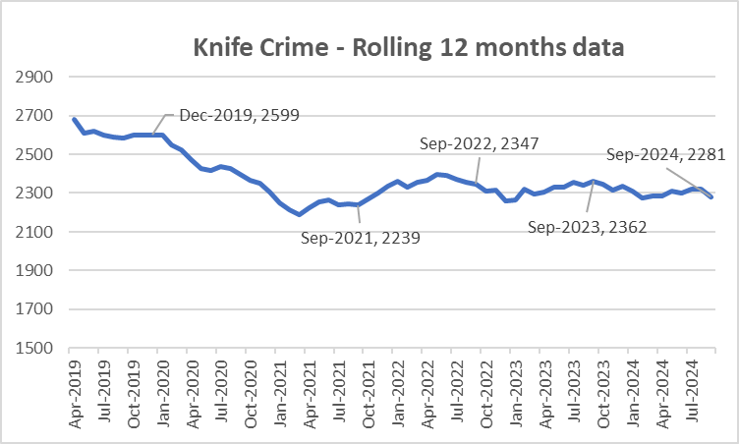

3.3.2 The most recent update nationally is to end of June 2024 – The below table looks at knife crime per million residents when compared to the Jan-Dec 2019 baseline. The below table compares with others in our most similar group.



3.3.3 It should be noted that West Yorkshire Police is one of 40 forces which uses a national methodology for recording knife crime. The remaining forces will be using the same methodology soon, but until then, national comparisons are problematic. Also, data for West Midlands is provisional due to a move to a new computer system. Greater Manchester Police (GMP) have been unable to supply offences involving knives or sharp instruments data from July 2023 due to an IT issue in processing these data. Figures for GMP are not included

**3.4 Reduce the number of ASB incidents**

3.4.1 Anti-Social Behaviour (ASB) incidents have increased marginally by 1.7% (463 incidents) when comparing the latest 12 months to September 2024 with the previous 12-month period.

3.4.2 The number of ASB incidents was significantly impacted by crime recording improvement activity. But now that difference is starting to slow as can be seen in the below graph.

3.4.3 Work has been undertaken with the Call Management Centre and the Neighbourhood Support Officers to ensure that West Yorkshire Police is better at identifying a crime from a victims / caller’s initial contact in relation to Anti-Social Behaviour (ASB).

**3.5 Keep Neighbourhood Crime below baseline**

3.5.1 The Force continues to make significant reductions in Neighbourhood Crime. Figures for the latest 12 months to September 2024 report that Neighbourhood Crime offences have fallen by 26% when compared to the national baseline period (Jan-Dec 2019) equating to almost 12,000 fewer victims. Notable reductions for residential burglary (down 38%), personal robbery (down 13%), theft from person (down 29%) and theft from a vehicle (down 35%) have been reported. In comparison to 12-months ago Neighbourhood offences are relatively unchanged (up 0.1%).

3.5.2 The below table looks at these crime types to break down the overall figures.



3.5.3 We are beginning to see that some areas have seen an increase in offending, whereas other that were higher have now reduced. Although Theft Of Motor Vehicle continues to be the only area above the 2019 baseline, it is now showing a reduction to the previous year whereas other types of vehicle crime are seeing increases.

3.5.6 Compared with our most similar group, West Yorkshire has one of the largest % change in comparison to the baseline. (offences per 100,000 population).



**3.6 Monitor cyber-attacks on businesses via WYCA survey**

3.6.1 This data is not available currently.

**3.7 Increase proportion of workforce from ethnic minorities**

3.7.1 Overall the proportion of the total WYP workforce from ethnic minorities is at 8.7% but officers are currently above this at 9.8%. Although staff numbers are lower at 6.7% this is still an increasing trend.

3.7.2 As reported nationally, West Yorkshire Police exceeded its target for recruitment of officers and although the overall proportion of officers and staff from ethnic minorities continues to be below that of the West Yorkshire population, during recruitment this proportion was much higher and nearer to the target.

**3.8 Increase proportion of female officers**

3.8.1 West Yorkshire continues with high numbers of female officers - this has increased from 35.5% in 2019 to nearly 39.6% currently. Police staff continue to have a high number of female members, with that percentage not changing over the years.

3.8.2 The latest position in-Force in relation to faith, sexual orientation and disability of officers, staff and PCSO’s has been updated. Following work to address the completeness and accuracy of the data, the number of employees not recording their protected characteristics has fallen significantly from around 80% in 2021 to just 6.0% for officers,4.5% for police staff and 4.1% for PCSOs.

**3.9 Reduce numbers of Killed or Seriously Injured on roads in West Yorkshire**

3.9.1 Numbers of KSIs on the roads in West Yorkshire is currently decreasing and this is the focus of the Vision Zero meetings in West Yorkshire.

3.9.5 The number of fatal road collisions remained relatively stable between 2019-2021 but increased in 2022 however the numbers in 2023 and for the latest 12 months to the end of July 2024 have started to fall. The number of serious collisions reported an upturn from 2021 onwards. The latest serious collision statistics for the 12 months to July 2024 remain at a relatively high level but are currently below the numbers reported in 2022 and 2023.

3.9.7 Each area now has a dedicated Vision Zero meeting where these numbers are scrutinised.

**3.10 Increase number of additional officers and staff in comparison to April 2021 baseline**

3.10.1 The Mayor’s Pledge for 750 more frontline officers and staff was met in April 2024. For more information please see previous Police and Crime panel paper.

**4. Responding to Multiple and Complex Needs**



**4.1.1 Monitor VRU early intervention programme attendee figures**

4.1.2 As part of its monitoring information for the Home Office, the Violence Reduction Partnership must show the impact of its work by counting the number of young people (and others) that it reaches.

4.1.3 The VRP sends these figures quarterly to the Home office to show the impact of its interventions. These interventions have been detailed in previous papers to the panel and will continue to be part of the impact of the Police and Crime Plan.

**4.2 Reduce the number of repeat missing persons.**

4.2.1 Number of Missing persons per 1,000 population.

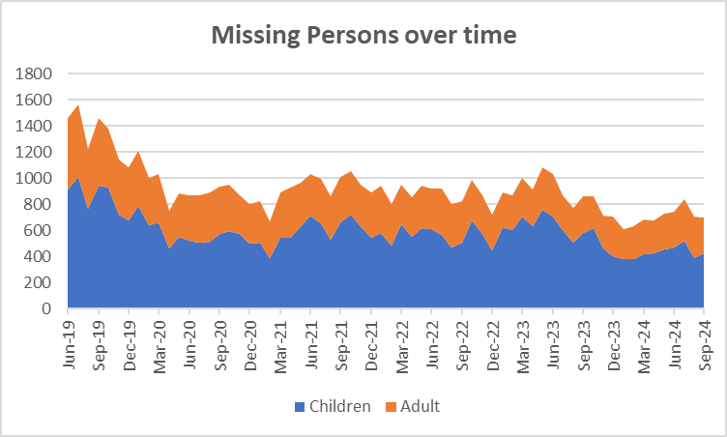Over the last 12 months there have been 8853 missing persons occurrences (including repeats). The trends for this are as follows.



4.2.2 The next table looks at the numbers of repeat missing occurrences.

4.2.5 The number of repeat missing persons is detailed above. This stands at 33.9% for missing children and 13.1% for missing adults.

**4.3. Reduce Re-offending Rate for Drug Related Crime**

4.3.1 Due to the time lapse required to ensure offences are taken into consideration, the re-offending rates are for offenders who were convicted 12 months ago.

4.3.2 The current figures show that there has been a 0.8% reduction in this rate in comparison to the same time 12 months before.

4.3.3 Work is ongoing with the Senior Responsible Officers for the Combatting Drugs WY partnership with the Deputy Mayor bringing all 5 districts together to discuss common problems and share best practice.

4.3.4 West Yorkshire Reducing Reoffending Partnership Board: This is the current iteration of the board convened by the Mayor and chaired initially by the Criminal Justice Policy Manager. The intention of this board is to add value to existing Reducing Reoffending Partnerships within districts and their work with Criminal Justice partners including Youth Justice.

**4.4 Reduce the number of First-time entrants to the CJS**

4.4.1 Following a user consultation published in February 2023, the MOJ have concluded first time entrants’ statistics will only be published annually as part of the First-time entrants (FTE) into the Criminal Justice System and Offender Histories publication.

**4.5 Increase number of offenders referred to drug treatment services via Liaison and Diversion**



4.5.1 Figures relate to referrals to drug services across the five districts. Figures provided by West Yorkshire All Age Liaison and Diversion Service.

4.5.6 We have not yet received the figures for Q2 so the above is the same as the last quarter.

Appendix 2

**Cyber Crime**

**Reports, referrals, and outcomes for**

The below data is for October 2023 to September 2024

Cyber Crime reporting

The above is for Cyber Crime only the picture for Fraud is as follows:

The below is for both Cyber Crime and Fraud

For business Cyber Crime **only** the current picture is as follows:

|  |  |
| --- | --- |
| **Acquisitive crime** | Acquisitive crime is defined as an offence where the offender derives material gain from the crime. Examples include shoplifting, burglary, theft, and robbery. |
| **BAME** | BAME stands for Black, Asian and Minority Ethnic and is used to describe people from any of these ethnicities. |
| **Child sexual exploitation and abuse** | Sexual exploitation of children and young people under 18 involves exploitative situations, contexts, and relationships where young people (or a third person or persons) receive 'something' (e.g., food, accommodation, drugs, alcohol, cigarettes, affection, gifts, money) because of them performing, and/or another or others performing on them, sexual activities. |
| **Community Safety Partner** | Several different organisations have a role to play including local councils, fire and rescue service, health and probation services and housing providers etc. These are often referred to as local community safety partners. |
| **Conviction rate** | This measure is calculated by dividing the number of defendants convicted by the total number of defendants prosecuted in the court during the period in question. The total number of defendants prosecuted in the court includes those charged by the police and Crown Prosecution Service but whose cases were dropped. |
| **Crime rate** | The crime rate used in this document refers to the number of offences committed per 1000 people in the population. |
| **Cyber crime** | Can be seen in two parts: cyber-enabled crime, where crimes that may be committed without computers are instead committed using computer networks (for example fraud and bullying); and pure cyber-crime where the offence can only be committed using computers (for example computer hacking or use of malicious software). |
| **GAP**  **Human trafficking** | Anticipated Guilty Plea  Human trafficking is the trade of humans, most commonly for the purpose of forced labour or commercial sexual exploitation by the trafficker or others. |
| **IOM** | Integrated Offender Management (IOM) is an overarching framework that allows local and partner agencies to come together to ensure that the offenders whose crimes cause most damage and harm locally are managed in a coordinated way. |
| **IVR** | Interactive Voice Response, which is the automatic update to listeners to make sure they are holding on for the right reason (i.e. could their call be dealt with easier online or should it be directed elsewhere) |
| **Ineffective trial** | An ineffective trial occurs when the trial does not go ahead on the date planned due to action or inaction by one or more of the prosecution, the defence or the court and a further listing for a trial is required. |
| **Most similar police groups/family/forces**  **NGAP** | Most Similar Groups (MSGs) are groups of police force areas that have been found to be the like each other based on an analysis of demographic, social and economic characteristics which relate to crime. Each police area has its own group of up to seven police areas to which it is ‘most similar’. MSGs are designed to help make fair and meaningful comparisons between police areas which share similar characteristics, rather than, for example, comparisons with a neighbouring police area.  Anticipated Not Guilty Plea |
| **Operational functions** | Operational functions include things like patrolling neighbourhoods, responding to 999 calls, roads policing and protecting vulnerable people. |
| **Outcomes/detections** | Outcomes/detections are used by the Home Office to describe the result of a police investigation following the recording of a crime. They can include cautions, charges, fixed penalty notices, cannabis warnings etc. There are 21 categories of outcomes. |
| **PEEL**  **Positive Outcomes** | HMICFRS carry out several thematic annual inspections throughout the year, these are drawn together into a wider PEEL assessment which stands for Police Effectiveness, Efficiency and Legitimacy.  Outcomes which fall into the first 8 categories for Police outcomes, these include mostly charges, cautions and community resolutions. |

**Find out more.**

westyorks-ca.gov.uk

@WestYorkshireCA

enquiries@westyorks-ca.gov.uk

+44 (0)113 251 7272

All information correct at time of print (December 24)