Appendix A
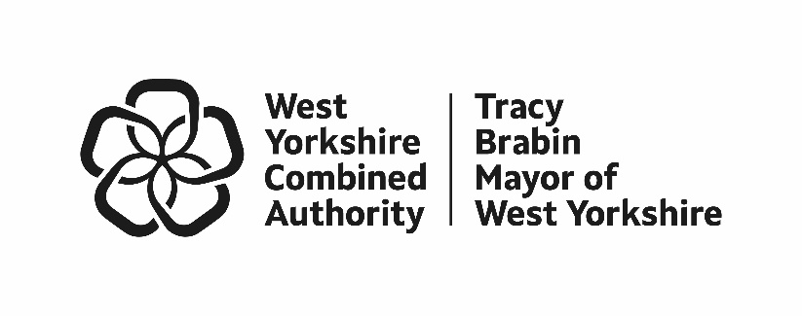
Precept Consultation Results 2025/26 Budget

The below is a summary of our findings from our 2025/26 Police Precept Consultation, which encompasses an online survey, a postal survey and an in-person survey which allowed us to respond to questions, capture dialogue and have an open conversation about police funding.

- Online and Postal Survey
  - Our online and postal survey consultation on the Mayor’s proposal for the Council Tax police precept ran between the 5th of December 2024 and 22th of January 2025. This is a longer consultation period than in previous years, giving residents a greater opportunity to have their say.

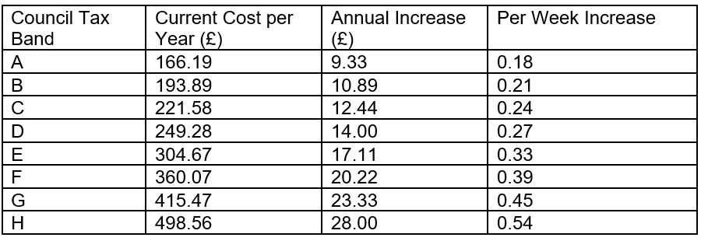
  - Residents were invited to respond to the proposal of an equivalent £14 annual increase on Band D households, corresponding to 27 pence per week. Respondents were provided with the table below so that they could understand the weekly cost to residents for the different Council Tax bands.

  - The consultation was promoted extensively online, including the use of targeted advertisements on social media platforms to encourage certain under-represented groups to respond, through the Combined Authority’s ‘Your Voice’ consultation platform, and circulated to our network of partners across West Yorkshire to help reach a wider audience. We also made the decision early in January to extend the online survey deadline from the original date of 17th of January to 22nd of January to attract a greater number of responses. This work was accompanied by a postal survey which reached 7,100 randomly selected West Yorkshire households.

  - The precept consultation was promoted with two press releases and via two Community Alerts (a subscriber-based messaging system) to both launch the survey and to mark the final opportunity and the extended deadline. These releases were featured in the Bradford T&A, Keighley News, Yahoo News and online sites ‘Doing Good Leeds’ and ‘Ground News’. The Deputy Mayor for Policing and Crime also promoted the consultation during broadcast interviews with BBC Radio Leeds and Global News.

  - External newsletters shared by the West Yorkshire Combined Authority contained articles about the precept consultation and internal items were posted across the organisation. In addition, a partner communications toolkit was produced to aid the dissemination of the message. This included a QR code, social media messages, key messages, a dedicated video from the Deputy Mayor for Policing and Crime and an intranet item.

  - Following collaboration with West Yorkshire Police, online public engagement and customer contact interactions also contained details of the consultation opportunity. From a social media perspective, the West Yorkshire Combined Authority posted numerous organic messages across its various channels and ran a ‘paid for’ social media campaign during the consultation period.

- In-Person Consultation

  - This section summarises the in-person consultation gathered as part of the 2025/26 Police Precept Consultation. The findings are based on five key in-person engagement opportunities held across West Yorkshire with representation across all five districts during January 2025.

  - The objectives included:
- Gathering feedback on the precept proposal from a diverse group of residents, specifically under 35s.
- To understand if those we speak to support an increase in the Council Tax to support the Police Precept, and if they were willing to pay the increase.
- Discuss areas of policing where people would like to see potential investments or savings.
- Obtain general feedback on policing and understand how this impacts on precept comments.

  - Methodology

    - Following on from the recent Police and Crime Plan consultation we wanted to target public spaces with a high footfall where we could speak in person to people about the police precept. The consultation, in the form of an in-person survey, reflected the ask within the online/postal survey but afforded greater opportunity for discussion with members of the public.

    - Large display boards showing police income and spend, and the suggested increase was printed, and these drew local people into a discussion in shopping centres across Bradford, Calderdale, Kirklees, and Leeds, and in Wakefield bus station. Attendance times and days varied and included evenings and weekends to maximise opportunities for involvement. The shopping centres were supportive, promoting the engagement on their social media channels. Opportunities were also advertised via the West Yorkshire Police Community Alert system.

  - Precept Proposal 2025/26

    - A diverse group of 17 people took part in a focus group on 28 November 2024 to inform the 25/26 precept consultation. They reviewed and offered feedback on the opening text, survey introduction, precept explanation along with the key questions for both the online and in person survey.

    - Key feedback included:
    - Requests to make the key questions less wordy
    - Support for the opening introduction and positive feedback on the funding gap information, which included police spend and potential increases with annual and weekly figures.
    - Support for free text options so people could state any objections and their reasons for this
    - Requests for a ‘don’t know’ option should be included with the ‘Yes’ and ‘No’ response to questions 2 and 3 as follows:
      - Q1. If you pay council tax in West Yorkshire, what band is your property?
      - Q2. Do you support the proposal to increase the council tax police precept?
      - Q3. Are you willing to pay the increase to your council tax?

We also asked the focus group about an option to pay more than the £14 increase (based on Band D). The feedback was overwhelmingly negative with comments suggesting it would not be received well, ‘’ it makes people feel guilty, makes me feel powerless’’ and ‘’it's already challenging asking for more to standstill so this would be pointless’’.
- Survey Results

  - Due to the difference in questions between the online/postal survey and the in-person consultation the two types are analysed separately below.

  - Combined Online and Postal Survey Results

    - West Yorkshire has a population of approximately 2.35 million. To ensure a confidence interval of 99%, with a 5% margin of error, we needed a sample size of 666 respondents or more to get a representative result for the whole of West Yorkshire.

    - Residents were asked:
- Whether they support the proposal to increase the Council Tax police precept; and,
- Whether they are willing to pay the increase to their Council Tax.

    - By the close of both surveys 1,653 residents had responded to the consultation.

    - Headline results:
- 58% of respondents supported the proposal to increase the Council Tax police precept.
- 58% of respondents are willing to pay the increase to their council tax.
- 58% of respondents supported the proposal to increase the precept in 2025/26; a 13 point decrease on last year’s result.
- 60% of respondents for the postal survey supported the proposal to increase the Council Tax police precept, compared to 57% of respondents for the online survey. These results have been combined to produce a headline figure of 58% support.
- 74% of respondents were from Band A to D households, with Band D households the most frequent (22% of the total).

 | Yes | No | Respondents
Q1. Do you support the proposal to increase the Council Tax police precept? | 58% | 42% | 1,624
Q2. Are you willing to pay the increase to your council tax? | 58% | 42% | 1,620

Q: Respondents'  Council Tax Band | % of all respondents | No. of respondents | % supporting precept increase
A | 19% | 302 | 54%
B | 14% | 226 | 56%
C | 19% | 301 | 63%
D | 22% | 363 | 58%
E | 8% | 128 | 61%
F | 4% | 72 | 62%
G | 3% | 43 | 58%
H | <1% | 6 | 33%
Don't know / not specified | 11% | 173 | 55%
Total | 100% | 1,614 | 58%

  - Headline In person Consultation Results

    - These results are based on 502 responses.

- 51% of all those we spoke to support the proposal to increase the council tax, and 50.2% said they were willing to pay it.

People spoke about supporting the principle of the increase but were worried about being able to pay it.

- 28% of those we spoke to did not know their council tax band, of these 65 people did not support the proposal to increase and 61 were not willing to pay.

People who did not know their council tax band were less likely to support the increase.

    - Information on those we spoke to is as follows:

- 57% of those we spoke to were in bands A to C with 121 people in band A.
- 36% of people we spoke to were aged 39 or younger and 50.2% were under 49.
- We spoke to 278 women and 136 men.
- Over a quarter of people stated they had a disability, and some people shared how this impacted their views on vulnerability and contact with the police.
- 31% of people said they were Asian, Asian British, Black African, Black Caribbean, Black British and mixed race.

  - Results by Demographic

    - The following section looks at the different survey types and the results by demographics so that we can understand the results in more detail.

    - Results by Demographic: Online Survey:

Q: Respondents' status* | No. | %
West Yorkshire resident | 1271 | 99%
Business owner in West Yorkshire | 62 | 5%
Working in West Yorkshire | 251 | 19%
Total | 1290 | 100%
*Note: respondents could select more than one option.

Respondents’ District | % of all respondents | No. of respondents | % supporting precept increase
Bradford | 24% | 310 | 54%
Calderdale | 10% | 133 | 51%
Kirklees | 15% | 191 | 55%
Leeds | 33% | 416 | 61%
Wakefield | 17% | 222 | 59%
West Yorkshire | 100% | 1,272 | 57%

Q: Respondents'  Ethnicity | % of all respondents | No. of respondents | % supporting precept increase
Black and minority ethnic groups | 8% | 98 | 44%
Preferred to keep ethnicity private | 13% | 163 | 33%
White | 79% | 991 | 62%
Total | 100% | 1,252 | 57%

    - Results by Demographic: Postal Survey:

Q: Respondents' status* | No. of respondents | % of all respondents
West Yorkshire resident | 356 | 100%
Business owner in West Yorkshire | 19 | 5%
Working in West Yorkshire | 36 | 10%
Total | 356 | 100%
*Note: respondents could select more than one option.

Respondents’ District | % of all respondents | No. of respondents | % supporting precept increase
Bradford | 22% | 78 | 63%
Calderdale | 12% | 43 | 67%
Kirklees | 20% | 70 | 56%
Leeds | 32% | 114 | 60%
Wakefield | 14% | 49 | 51%
West Yorkshire | 100% | 354 | 60%

Q: Respondents'  Ethnicity | % of all respondents | No. of respondents | % supporting precept increase
Black and minority ethnic groups | 9% | 31 | 45%
Preferred to keep ethnicity private | 5% | 16 | 31%
White | 86% | 287 | 64%
Total | 100% | 334 | 60%

    - Results by Demographic: In-person consultation:

Q: Respondents' status* | No. of respondents | % of all respondents
West Yorkshire resident | 494 | 98.4
Business owner in West Yorkshire | 1 | 0.19
Business owner and resident | 7 | 1.39
Total | 502 | 100%
*Note: respondents could select more than one option.

Respondents’ District | % of all respondents | No. of respondents
Bradford | 20.09 | 89
Calderdale | 19.18 | 85
Kirklees | 10.83 | 48
Leeds | 20,31 | 90
Wakefield | 29.11 | 129
Not stated | 0.45 | 2
Total | 100 | 443

Q: Respondents'  Ethnicity | % of all respondents | No. of respondents
Black and minority ethnic groups | 31.2 | 128
White | 68 | 279
Other | 1.5 | 6
Total | 100 | 413

  - Survey Results Analysis

    - Regarding the online and postal survey results, those in the Council Tax brackets C, E and F were the most supportive of the increase to the council tax police precept, whilst brackets A, B and H were the least supportive.

    - Across both the online and postal survey, respondents from black and minority ethnic groups were less supportive of the increase to the council tax police precept than those who identified as white.

    - The online survey results show that residents from Leeds were the most supportive of the increase and those from Calderdale were the least. Regarding the postal survey, those from Calderdale were the most supportive of the increase, and those from Wakefield were the least supportive.

    - If we look at the online and postal survey results, those who have responded are broadly proportionate to the make-up of West Yorkshire at a district level. In the online survey, Kirklees and Leeds are slightly under-represented whereas in the postal survey, this is the case for Bradford, Leeds and Wakefield. The in-person survey saw a high number of respondents from Wakefield.

    - We acknowledge that those who responded to the online and postal survey are not reflective of the different ethnicities that make up West Yorkshire. The in-person engagement sought to bridge this gap and 31.2% of all those we spoke to face-to-face identified as black or from an ethnic minority group.

  - Free Text Comments

    - There were free text opportunities throughout the survey so people could explain the reasons for their responses which included space for people to share where they would like to see investments or savings; and an opportunity to add any general comments regarding funding for West Yorkshire Police. Below is a summary including quotes which reflects the feedback provided with some additional comments regarding the consultation.

    - Comments for Supporting/not Supporting the Proposal

Around 20% of all the people we spoke to left comments in which they shared either positive or negative experiences with individual officers or with individual incidents/encounters.
“The police do an absolutely brilliant job; the increase is definitely justified in my view.’’
“Why would I support the increase I never see them.”
“I think investment in better policing is needed. Crime is too high in my area, and it needs to be safer.”
“Why should I have to pay for the police, it’s not on, authorities should pay more not us.’’
“I am not happy about the increase and worry people can’t afford to pay it, but I understand it’s needed and necessary.”
    - Investments and Savings

This was by far the most commented on section with nearly a third of all the people who we engaged responding to the free text.

- Investments – By far, the majority of people spoke about police officer visibility and Neighbourhood Policing. Others highlighted key policing, crime and community safety issues that mattered to them, often based on personal experience. These included: Serious Violence, Child Exploitation, Safety of Women and Girls, Drugs, Online Crime, Shoplifting and Burglary.

- Savings – People really struggled to think of areas of policing where they thought savings could be made but most of the comments shared were around administration and bureaucracy, prosecutions and court delays and other areas impacting policing such as prison and probation services.

    - Final Comments

Less than 10% of people left any final comments on funding the police and the responses were overall very similar to comments supporting/not supporting the proposal, officer visibility was a common theme.
“The police do a really risky job, I am happy to pay an increase they need the right pay, resources and equipment to do their job.”
“I had a serious incident, they are still investigating it, it’s taking ages.’’
“With better funding we will get better policing.
“Why would I agree to pay more if we aren’t getting any more.’’
“Money for policing should be the same irrespective of the council tax band you live in – we all get the same service don’t we.’’
“I was worried about an increase but now I know it’s only a few pence extra a week I don’t mind.’’
“The police are amazing.”
    - Comments on the Consultation

The in-person consultation offered a great opportunity to talk to residents about police funding. Lots of people we spoke to were surprised to learn about the police precept element of their Council Tax and welcomed the information provided. Whilst there was a view that residents would have to pay the increased precept, whatever the cost, most of the people we spoke to welcomed the opportunity to share their views and opinions.

As part of the consultation we spoke to many more people who did not wish to complete a survey but offered feedback on the Council Tax, West Yorkshire Police and the Mayor’s policing priorities.

