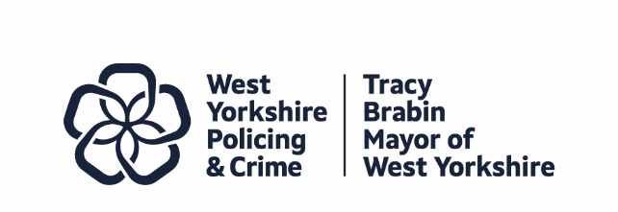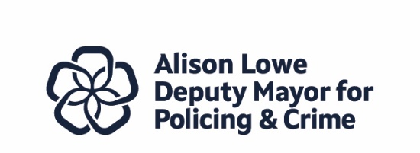
Item 6
Report to: | Police and Crime Panel
Date: | 7th November 2025
Subject: | Recruitment, retention and attrition, including PDRs and the Force IDM system.
Report of: | Tracy Brabin, Mayor of West Yorkshire
Author: | Wendy Stevens – Research and Performance Manager

- PURPOSE OF THE REPORT

  - The purpose of this report is to look at the current patterns of recruitment, retention and attrition in West Yorkshire Police (WYP) including the work completed to introduce the newly modified Performance Development Review (PDR) system.
  - During a meeting of the Police and Crime Panel the Chief Constable assured members that the success of the modified PDR system will be based on the individual meetings between supervisors and their staff, so this paper includes an update on the IDM system which tracks these meetings.
- INFORMATION

  - Workforce Numbers
2.1.1 The following is provided from the WYP Workforce Analysis and Resourcing Forecast (WARF) Live PowerBi tool (as of 31 July 2025).
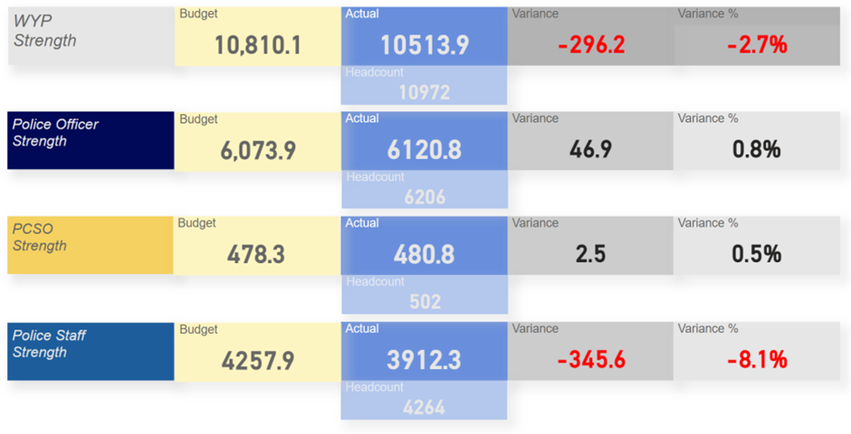
2.1.2 The above confirms the overall force position remains relatively static and subject to only minor variation, influenced by over-budget police officer numbers being offset by a steadily reducing PCSO strength and similarly with the wider police staff cohort which has been reducing in accordance with the force’s financial plans. There are still plans to reduce the numbers of PCSO’s but the budget figures show that attrition numbers are currently lower than expected so numbers are currently over budget.

2.1.3 The number of student officers on Districts has not varied significantly; in December 2024, student officers accounted for 19.2% of all officers on Districts. In July 2025, that figure has reduced slightly to 17.8%.

2.1.4 A strong police officer recruitment pipeline is maintained to ensure the force meets Home Office expectations relating to officer numbers as determined by the Police Uplift Programme (PUP) and the more recent Neighbourhood Policing uplift of 100 additional officers. The force is on-track to meet all recruitment additionality expectations.

2.1.5 Increasing and maintaining Detective Constable (DC) numbers continue to be a challenge for the force – a situation replicated across policing. The force has made several interventions to mitigate the impact, including:

- Increasing the proportion of student officers recruited via the Direct Entry DC route.
- Introducing the DC Career Pathway to provide student officers on the DC route the opportunity to rotate between crime functions to gain wider experience and exposure.
- Maintaining a Gold group in response to the national workstream focused on the Recruitment, Retention, Wellbeing of Investigators (RRWIG).

  - Attrition Profile
2.2.1 In terms of police officer attrition profile, the force has improved. The overall police officer attrition position continues to be positive with the force performing better than the national average for E&W forces; 5.71% compared with 6.8%.
2.2.2 In terms of student officers, the current (31 July 2025) 12 month rolling attrition figure of 9.5% is a slight improvement on the position on the 31 January 2025 which was 9.6%. Improving Student Officer attrition continues to be a key priority for the People Directorate with a number of recent improvements to the force approach, including the introduction of a “Stay Interview” for all student officers. Furthermore, the force is reviewing the current pre-appointment awareness sessions for potential applicants with a view to further enhancing their approach to ensure potential student officer candidates have as full an understanding of the benefits and challenges of being a student officer before they undertake the application process.
2.2.3 Whilst the force maintains a positive position for police officers, attrition performance in relation to Special Constables continues to be a challenge with the force currently at 30.6%. It should be noted, however, that a significant proportion of Special Constable “leavers” are actually those individuals joining WYP, or another force, as a Police Constable. The table below details the numbers of WYP Special Constables who have either joined WYP, or another force, as a Police Constable over the last five years:
2.2.4
Year | Number
2025 | 1 (into WYP)
2024 | 12 (into WYP)
2023 | 9 (into WYP)  3 (joined other Forces)
2022 | 25 (into WYP)  4 (joined other Forces)
2021 | 13 (into WYP)  4 (joined other Forces)
2020 | 45 (into WYP)  7 (joined other Forces)

2.2.5 In summary, whilst there are some positive indicators with regard to attrition within the force, there continues to be challenges and constant focus on how they might improve our performance. Attrition is a key measure of success in the new People Strategy 2025-29.
2.3 PDR (IDMs)

2.3.1 The force approach to PDRs has changed following the area for improvement (AFI) received following the 2023 PEEL inspection. In addition to modifications to the system, to make it much more user friendly and in response to user feedback, the force has introduced Individual Development Meetings (IDMs). Every officer and staff member should be having an IDM at least every three months, to focus on the individuals:

- Wellbeing
- Performance
- Development

2.3.2 IDMs were introduced on the 1 April and Quarter 1 resulted in a 98.22% IDM completion rate albeit some people were exempt (upcoming retirees, etc.). The PDRs of every officer and staff member includes four force objectives with managers expected to set at least one further personal objective for their direct reports. This is the focus of Q2; to ensure the completion rate remains at the level of Q1 and that each member of WYP has at least one individual PDR objective added to their PDR in addition to the generic force objectives.

- EQUALITY, DIVERSITY AND INCLUSION BENEFITS AND IMPLICATIONS

  - We have seen that previous positive action by WYP has resulted in a higher number of recruits from ethnic minorities.
  - This work is continuing as part of the focus of the Police Race Action Plan and the most recent report states that representation has increased for Black and Black heritage officers and staff by 15%, at that time, the number of staff that self-define as Black or Black heritage stood at 158. Work is still ongoing through the Positive Action team.
  - Although the focus of the Police Race Action Plan is for Black or Black heritage officers, this positive action continues for all ethnic minorities.
  - This work also extends to retention with particular focus currently on the attrition of ethnic minority officers in the disciplinary process.
- IMPLICATIONS FOR YOUNG PEOPLE IN WEST YORKSHIRE

4.1 n/a

- FINANCIAL IMPLICATIONS

  - The need to recruit officers to meet the government pledges is discussed in the Mid Term Financial Forecast for which there is also a paper at the November panel meeting.

- LEGAL IMPLICATIONS

  - n/a

- EXTERNAL CONSULTATION

  - Understanding the recruitment process and how this affects minority ethnic officers has been the subject of much external and internal consultation.
  - This is also part of the topics under discussion by the various scrutiny groups held by West Yorkshire Police

- RECOMMENDATIONS

  - That the panel accept this report and finalise the action

BACKGROUND PAPERS AND APPENDICES
None

CONTACT INFORMATION

Contact Officer: | Wendy Stevens
E-mail: | Wendy.stevens@westyorks-ca.gov.uk

