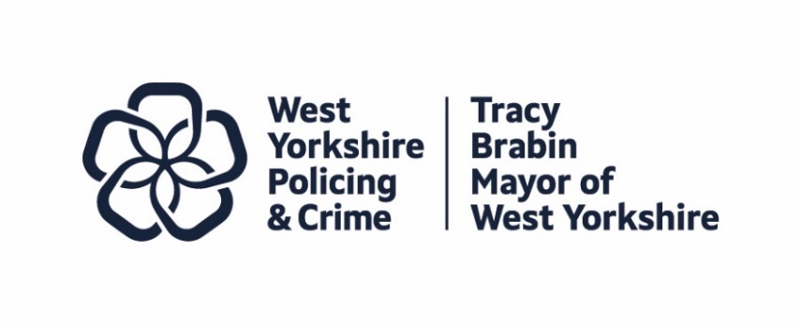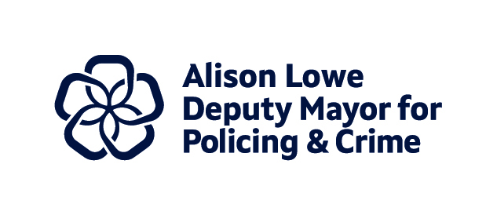
ITEM 6
Report to: | Police and Crime Panel
Date: | 11th April 2025
Subject: | Violence Reduction Partnership Update
Report of: | Alison Lowe, Deputy Mayor for Policing and Crime
Author: | West Yorkshire Violence Reduction Partnership, West Yorkshire Combined Authority

- PURPOSE OF THE REPORT

  - To provide an update to the Police and Crime Panel on the work and progress of the Violence Reduction Partnership (VRP).
  - To provide the Police and Crime Panel with information on the Serious Violence Legal Duty, and the collaboration between the VRP and key partners in this area.

- OVERVIEW
  - The VRP was first introduced in 2019 following funding from the Home Office to establish a Violence Reduction Unit (VRU) in the county. It is one of 20 VRUs across England and Wales.
  - Since 2019 VRUs have been tasked with leading and co-ordinating the local response to serious violence. With responsibility from the Home Office to deliver a ‘whole system’, public health approach to tackling violence, by bringing together key partners to identify the local drivers and root-causes of serious violence and agree and implement a multi-agency response to them.
  - Delivery guidance for 2025-26 has indicated that VRUs will have a key role to play in supporting the delivery of the Government’s Safer Streets Mission. Including the requirement this year, to pilot the delivery of Prevention Partnerships and establish a local mechanism to identify, assess and refer into evidence-based support, children and young people displaying an increased vulnerability to being drawn into crime.
  - In June 2023, following the implementation of the Serious Violence Duty in the January, the Violence Reduction Unit undertook a re-brand to become known as a VRP to better reflect this being a partnership approach to serious violence.
  - Under the Serious Violence Duty, the Mayor holds powers to distribute funding, convene partnerships and to scrutinise the response of the specified authorities.
  - The Serious Violence Legal Duty (SVD) places joint, and equal, responsibility on Police, Local Authorities, Probation, Fire and Rescue, Youth Justice Services (YJS) and Integrated Care Boards (ICB) to, through a partnership approach, identify and respond to the causes and impact of serious violence. The VRP are not a specified authority under the SVD but have played a key role in supporting partners to prepare for the new responsibility.

- EQUALITY, DIVERSITY, AND INCLUSION
  - Various equality, diversity and inclusion factors are embedded in the work to address serious violence in West Yorkshire and are touched on in the following report.

- IMPLICATIONS FOR YOUNG PEOPLE IN WEST YORKSHIRE
  - The focus of the work of the VRP is on children and young people, although work is undertaken more widely to address wider issues linked to serious violence.
  - Specific work has been undertaken to put children and young people at the heart of the work of the VRP, and that of its partners, particularly through the development and implementation of Child First. This work aims to follow a trauma informed approach and to put children’s voices at the centre, involving them in decisions whenever possible.

- FINANCIAL IMPLICATIONS
  - There are no financial implications to be considered in this paper.
  - Top level information on budget allocations for the VRP and the SVD can be found in the following report.

- LEGAL IMPLICATIONS
  - There are no legal implications to be considered in this paper.

- SUPPORTING PAPERS
- Violence Reduction Partnership Update
  - Appendix A - Serious Violence Funded Interventions

CONTACT INFORMATION

E-mail: | VRP@westyorks-ca.gov.uk


West Yorkshire Combined Authority – Violence Reduction Partnership – Serious Violence Duty

Update to the Police and Crime Panel – April 2025

- Introduction

  - The West Yorkshire Violence Reduction Partnership (VRP) was first introduced in 2019 following funding from the Home Office to establish a Violence Reduction Unit in the county. We undertook a re-brand to become known as a VRP in June 2023 to better reflect this being a partnership approach to serious violence.
  - We received £4,341,877.11 in 24/25 (Year 3) from the Home Office as part of a three-year arrangement to continue to lead and coordinate the local response to serious violence. For the financial year 2025/26 we have been allocated rollover funding of £4,341,877.11 to continue this work. A Delivery Plan setting out our approach for this next financial year was submitted to the Home Office in March 2025, as requested and we are awaiting confirmation this has been accepted.
  - As in previous years, there are several requirements attached to this grant, including the need to secure match funding from local partners in the form of resources, staffing or contributions to intervention delivery. Details of the required amounts for 2024/25 and 2025/26 are below:
2024/25: 20% of a VRU’s 2021/22 allocation = £674,000
2025/26: 20% of a VRU’s 2021/22 allocation = £674,000

- Serious Violence Duty Funding

  - Under the Serious Violence Duty, the Mayor holds powers to distribute funding, convene partnerships and to scrutinise the response of the specified authorities. Additional funding to support delivery of the Serious Violence Duty was allocated by the Home Office to the Mayor to cover labour and intervention delivery costs for specified and relevant authorities as outlined by the Duty. This money was for the periods January to March 2023, and financial years 2023-24 and 2024-25, and for West Yorkshire amounts to:
22/23 labour costs: £21,553.33, non-labour costs: £42,728.41
23/24 labour costs: £101,161.78, non-labour costs: £129,017.47
24/25 labour costs: £96,302.13, non-labour costs: £65,436.47

Further funding has been confirmed by the Home Office, with the amount available
for West Yorkshire to bid in for being a flat rollover of 24/25 funding. A collaborative
bid approved by all SVD organisations has been submitted to secure this funding:

25/26 labour costs: £96,302.13, non-labour costs: £65,436.47

- Serious Violence Legal Duty (SVD)

  - The Legal Duty commenced on 31 January 2023, placing joint and equal, responsibility on Police, Local Authorities, Probation, Fire and Rescue, Youth Justice Services (YJS) and Integrated Care Boards (ICB) to, through a partnership approach, identify and respond to the causes and impact of serious violence by:
- Sharing data, consulting with communities for the purposes of developing a Strategic Needs Assessment (SNA).
- Developing a Response Strategy based on the identified need.
- Publishing the Needs Assessment and Response Strategy (by 31 January 2025).
- Implementing, monitoring, and reviewing the Assessment and Response Strategy.
  - For the purposes of the SVD, local authority YJSs are a separate specified authority, and so are treated as independent to the local authority and therefore responsible for engaging with the partnership. The VRP are however not a specified authority under the SVD.
  - To respond to the duty and responsibilities, West Yorkshire partners agreed to build on existing partnership arrangements:
- Identified a Strategic ‘Duty Holder’ from each organisation who has strategic responsibility.
- On behalf of specified authorities, the VRP coordinated and facilitated the development of the Needs Assessment and Strategy in 24/25 along with a local profile for each district.
- Duty Holders to be held accountable to the Deputy Mayor through reporting to the West Yorkshire Serious Violence Strategic Executive where decisions regarding Serious Violence Duty and funding would be made.
- Implementation of the SVD Strategy is undertaken through place based (Community Safety Partnership/SV) partnerships with representation from SVD specified authorities at local level.
- All districts to develop an Implementation Plan detailing their delivery of the Strategy.
- On behalf of specified authorities, the VRP submitted the SNA and Response Strategy to the Home Office, both are published on VRP and Police websites (31 January 2025) with other duty holders also providing a link.
- SVD funding has been equally split amongst specified authorities and five CSPs (Community Safety Partnerships) to implement the Duty.
  - The VRP collated and submitted an advanced delivery plan to the Home Office at the end of January 2024 detailing activities to be delivered to the end of March 2025 and a further plan in March 2025 with proposed delivery to the end of March 2026. We are awaiting the outcome of this submission.
  - Standard monitoring is required for the end of each quarter from the five coordinating CSPs to include an Annex A (financial return) and Annex B (activity return).
  - The Knowledge Hub have continued to collaborate with all responsible authorities to develop the data ask in relation to the information suggested within the duty guidance. Regular data feeds have been secured from post partners, with health and prisons data requiring further attention.
  - Through regular SVD meetings with partners, it was felt necessary to develop two sub-groups which the VRP convene – one of Communications and one for data.
  - The Communications Group convenes experts from organisations across West Yorkshire to explore opportunities for collaboration on work and campaigns, agreeing shared messaging & development of a counter narrative.
  - The Analysis, research and performance sub-group met for the first time in March 2025 with broad representation from organisations across the County and discussed a number of areas for future collaboration.
  - The VRP continue to collaborate with partners on the development of their place-based response plans – plans that show how they are responding to the West Yorkshire Response Strategy.
- Future Delivery and VRP Activity

  - The Home Office have indicated the next financial year is one of transition and pivoting for the VRUs (VRP) nationally to ensure our activity is aligned to the wider Safer Streets Mission and objectives. This means considering the delivery of functions at a regional level beyond the current remit of VRUs, which to date have been focused on the prevention of public-space knife crime, with a view to deploying a whole system or public health approach across a broader suite of harms. These may include:
- Serious Violence, particularly public space knife crime
- Wider knife crime, including knife enabled robbery
- Violence Against Women and Girls
- Anti-Social Behaviour
  - The Government’s strategy to halve knife crime and serious violence is centred around the newly proposed ‘Youth Futures Hubs’ and ‘Prevention Partnerships.’ Although full details are yet to be released, the recent announcement of VRU funding for the financial year 2025/26 makes it clear that VRUs will play a key role in the design and development of the ‘Youth Futures Hubs’ and ‘Prevention Partnerships’.
  - The VRP are working hard with partners locally, and nationally, to ensure our approach is proactive, bold, and innovative to ensure we can lead in this area of work providing the best possible service and opportunities to the communities of West Yorkshire.
- Governance

  - The VRP continue to report into the Policing and Crime Executive within the West Yorkshire Combined Authority, and work with core members (as determined by the Home Office) and wider partners from across the system through our Partnership Delivery and Serious Violence Executive Group. Accountability also continues through the Home Office reporting arrangements.
- Key Areas of work
  - West Yorkshire Adversity, Trauma and Resilience Programme (ATR)
  - Since 2020 the VRP has worked collaboratively with the West Yorkshire Health and Care Partnership to co-lead a system wide programme focused on Adversity, Trauma and Resilience, to deliver on the shared partnership vision of,
  - Working together with people with lived experience and colleagues across all sectors and organisations to ensure West Yorkshire is a trauma informed and responsive system by 2030 and develop a whole system approach to tackling multiple disadvantage.’
  - The programme is facilitated by a governance structure that includes a West Yorkshire Strategy Group chaired by the Deputy Mayor for Policing and Crime, an Operational Network Group and workstreams focused on Staff Wellbeing and Trauma Informed Workforce Practice, Education, Criminal Justice and Reducing Violence Against Staff. This is complemented by development of resources, guidance documents, a website and during this financial year recruitment to a dedicated Training and Workforce Development role funded by the VRP. Partner leads in each Place are helping to drive this activity locally and centrally we are working with colleagues from across sectors such as health, prisons, education, housing, local authorities and the Voluntary, Community and Social Enterprise sector and notably organisations such as West Yorkshire Police, Liaison and Diversion, Probation and the Combined Authority.
  - Approximately 100 professionals from across West Yorkshire attended our first Criminal Justice themed conference during October 2024 and during the same month a premiere for the programmes trauma informed 4-part mini films was held, showcasing the progress within the programme and across the system to achieve the overall vision.
  - Dedicated capacity has been secured to focus on workforce development and training, which currently provides foundation level trauma informed training and is developing a train the trainer model to support sustainability of this activity and delivery of the overall ambition.
  - Our annual Knowledge Exchange took place in March, with the theme this year being Adversity and Trauma, Serious Violence and Inclusion Health. Guest speakers from across the county have shared good practice and learning and taken part in Panel Sessions answering questions from the audience, covering a range of topics including violence against women and girls, neurodiversity in the criminal justice system, racial trauma and palliative care.
  - Child First
  - The VRP launched an ambition to be a Child First VRP – putting children’s voices at the heart of everything we do, involving them in decisions whenever possible. Seeing children as individuals, recognising their strengths, and building positive relationships. We recognise there are fantastic examples of this work across West Yorkshire, so we are building on this to create a co-ordinated, consistent approach so all services a child meets will work in this way.
  - Over 450 children were engaged in the coproduction of our Child First Framework and is highlighted within the Police and Crime plan.
  - Following the launch of the Child First Framework, a National delivery group has been launched, chaired by the Deputy Mayor for Policing and Crime providing a collective space for organisations to work together more effectively to support, safeguard and secure better outcomes for children in the youth justice system. Key themes covered during the inaugural meeting include: The sharing of effective Child First practice, custody sites and alternatives to custody, child participation and engagement and the child’s journey through the system, as well as the importance of scrutiny panels.
  - Knowledge
  - All of our published VRP research is published at the following link.
  - In January 2025, five locality based Strategic Needs Assessments were developed and shared with partners along with a public facing West Yorkshire wide Strategic Needs Assessment.
  - A comprehensive evidence synthesis has also been produced exploring the influential factors linked to violence, the risk and protective factors that can influence or deter a person's involvement in violence and exploitation. This report is derived from the rolling research programme undertaken by the Knowledge Hub. The product complements the Needs Assessments to allow a holistic view to be taken in violence reduction activities.
  - Significant community engagement work was undertaken as part of the Serious Violence Duty survey (including in-person) The findings have been used to generate five locality-based reports and a West Yorkshire overview which fed into the Strategic Needs Assessment.
  - Finally, the refreshed WY wide Response Strategy has also been produced and published.
  - Key to successful delivery of programmes and interventions is a culture of continuous evaluation. The Knowledge Hub are managing several commissioned evaluations to explore the impact of the A&E Navigator programme, the Custody diversion programme, our Mentoring scheme in schools and the innovative Virtual Reality diversion programme.
  - A Theory of Change, Monitoring and Evaluation Toolkit was launched to support our drive for a culture of evidence-based practice. This toolkit aids partners across West Yorkshire to deliver informed interventions, capture relevant data and evaluate the impact of their work. Since the launch of the toolkit, a number of learning events have been held to help embed the practice across the partnership.
  - A multi-agency data dashboard has been developed for Serious Violence Duty holding partners to enable direct access to meaningful data sets including data from Police, Fire, Ambulance Service and Health.
  - We also collaborated on a project with the Vulnerability and Policing Futures Research Centre to test a quality standards framework they developed with the aim of strengthening existing responses to Online Child Sexual Exploitation and Abuse. This culminated in a final project event in March, which provided a forum for attendees to dig deeper into these quality standards and to provide insight, experience and understanding on how we can keep children and young people safe from online harms.
  - Intervention Delivery 2024/25
  - A programme of interventions are commissioned by the VRP and partners, designed to deter, reduce, and navigate people away from violence. Interventions are evidence led and are designed to develop evidence and learning through delivery of test bed pilots. These interventions operate on a West Yorkshire and place-based level working with partners across the VCSE and statutory sectors, including by providing funding to each CSP.
  - Up to the end of December 2024, 46 interventions have been funded through core VRP budget.
  - As in previous years, the Home Office requires us to deploy resource equivalent to no less than 30% of the value of our 2024/25 core grant on the delivery of interventions assessed by the Youth Endowment Fund toolkit as either high impact or moderate impact with a high evidence confidence rating. This equates to £1,368,197 during this financial year and has been used to fund 21 interventions including A&E Navigator services in Leeds, Bradford, Wakefield, Calderdale and Kirklees; a West Yorkshire Custody Diversion programme; a West Yorkshire Focussed Deterrence intervention with local authority partners and West Yorkshire Police and a small number of local interventions with CSPs.
  - A further £867,822 of our overall budget has been utilised to fund the remaining 25 interventions which includes mentoring activity in schools, education programmes using VR technology, targeted work focussed on online harms and a wide range of smaller community-based interventions to support a local CSP led response.
  - As part of the SVD activity there has been 11 interventions commissioned using the additional monies provided by the Home Office to support duty holders in their implementation and response to the SVD. An overview of all interventions is provided on Appendix B.
  - During the first nine months of 2024/25 these interventions combined have engaged with and supported 9281 young people aged 24 or under, 714 individuals aged 25 or over and provided workforce training and development to 264 individuals.
- Community Engagement

  - Leaders Unlocked
  - Leaders Unlocked are into their second year of delivery and have recruited additional children & young people aged 14-25 to join the cohort, providing them with the skills training, tools, and support. In February 2025, we held a West Yorkshire Youth Commission celebration event where the findings from their second-year work was presented. It followed peer to peer research with over 1700 young people. As part of the ‘Big Conversation’ they have continued to focus on their priority issues including:
- Rehabilitation and prevention
- Community relationships and life
- Attitudes, and violence towards women
- Gangs, drugs, and knife crime
  - The Youth Commissioners have also worked closely alongside our communications and engagement team in the co-production of a new campaign, aligned to these themes. Please see Communications section for more details.
  - Community Leaders Programme
  - After commissioning our first Community Leaders Programme in early 2024, it has gone from strength to strength. As part of our first cohort, twenty community leaders and emerging leaders took part in training over three months which included areas such as leadership, project management, community empowerment and trauma informed training.
  - A second cohort has subsequently followed, and a wider Community Leaders Network developed, which will be supported into 2025/26.
  - By investing in our community, we can ensure that they are equipped with the right skills and knowledge to increase their impact across the community.
  - A Community Leaders celebration event also took place in January 2025 acknowledging their work, as well as contributing to the launch of the Mayor’s latest Police and Crime Plan.
  - VRP Showcase Events
  - Over the past year our Engagement Programme Delivery Manager has led quarterly showcase events at different locations across West Yorkshire, platforming the progress of our partnership work in tackling serious violence. This has been an opportunity to share best practice and learning, whilst providing feedback. Our latest showcase event also saw the launch of the Mayor’s new Police and Crime Plan for West Yorkshire, with serious violence a cross-cutting theme.
  - Community Advisory Group (CAG)
  - We have continued to hold regular community advisory group meetings, supporting the VRP Needs Assessment and Response Strategy.
  - Theory of Change Engagement
  - Community sessions have been delivered to share learning from the Theory of Change, monitoring and Evaluation toolkit work.
  - Serious Violence Duty Consultation
  - Significant community engagement work was undertaken as part of the Serious Violence Duty survey (including in-person) The findings have been used to generate five locality-based reports and a West Yorkshire overview.
  - Equality, Diversity, and Inclusion
  - Equality, diversity, and inclusion is a golden thread throughout the work of the Violence Reduction Partnership and the role of engagement is crucial to ensure the voice of our communities are represented in our work. This has seen attendance at key public events in each District, such as Pride and University Fairs. This has been an opportunity to open dialogue on our work and ensure feedback shape our ongoing approach.
- Communications

  - “I Took a Seat” Youth Commission Co-Produced Campaign
  - In February 2025, we announced a brand-new flagship campaign called ‘I Took a Seat’, which remains ongoing. Co-produced by members of the West Yorkshire Youth Commission from beginning to end, it responds to recommendations contained in their first ‘Big Conversation’ report, covering key issues which include:
- Gangs, Drugs and Knife Crime
- Attitudes and Violence Towards Women
- Rehabilitation and Prevention
- Community Relationships and Life

  - The campaign focuses on encouraging behaviour change and signposting to support though online and offline mediums. This includes a targeted social media approach and visual assets in local bus stations.
  - Bradford Anti-violence Month
  - Back for its third year, Bradford’s Anti Violence Month returned across March 2025. The VRP Communications team supported in filming items for social media around a theatre piece called 'Blood's Thicker' and the use of virtual reality headsets to educate young people around knives and gangs.
  - It Does Matter
  - As part of a dedicated awareness week on Violence Against Women and Girls Week (from 1st March) we joined our partners in sharing the latest campaign 'It Does Matter'. It aims to educate and empower victims to report non-contact sexual offences, such as exposure and voyeurism, which have been historically overlooked in society as a form of violence against women and girls.
  - Trauma Informed- Mini-Film Premiere
  - Together with the West Yorkshire Health and Care Partnership, we launched a series of short films in October around our ambition to make West Yorkshire ‘trauma informed and responsive’ by 2030. It means recognising the impact that trauma and adversity can have for everyone, particularly after experiencing issues like serious violence. The films, which premiered at the Royal Armouries in Leeds, highlight how we can embed the approach across the criminal justice system and the ways it can protect people from harm.
  - Knives Claim Lives
  - In collaboration with the local Sam Teale Productions, we published a new short film entitled 'Knives Claim Lives' has been launched, addressing the choices and consequences of carrying knives. Supported by the West Yorkshire Violence Reduction Partnership and Safer Kirklees, the film aims to educate children and young people across the region about the deadly consequences of knife crime. It follows the story of a teenager drawn into gang culture, highlighting the fatal outcomes. The film can be accessed alongside a training package.
  - Co-Produced Animation
  - On International Youth Day in August, our West Yorkshire Youth Commission launched a co-produced animation about their ‘Big Conversation’ Report. The members also paid a visit to meet the VRP team, discussing issues and asking questions.
  - Child First Framework
  - In June, we publicised the unveiling of the pioneering ‘Child First’ approach for West Yorkshire and the launch of a new Framework aimed at placing children at the heart of decision making on local services and issues. To mark the milestone, Dance United Yorkshire and rappers performed at the Sunny Bank Mills complex in Leeds. Artwork and literature representing the experiences of children were also exhibited. To coincide with the event, we also published a new animation on the theme of ‘Child First.’
  - Summer Safety Campaign
  - Over the Summer of 2024, we worked alongside West Yorkshire Police on a safety campaign focusing on five key areas:
- Domestic abuse
- Drink and drug driving
- One punch manslaughter
- Sexual assaults
- Safe nights out
  - ‘Spotlight’ Features
  - We continue to film social media ‘spotlight features’ on our VRP interventions and partnership workstreams to showcase the work taking place across West Yorkshire to address serious violence. Most recently, we have captured content on our Community Leaders Network, the West Yorkshire Youth Commission, a Child Sexual Exploitation Research event, and local interventions to tackle violence against women and girls.
  - Partnership Newsletters
  - Since its inception in July 2023, the Violence Reduction Partnership has continued to publish an external Newsletter capturing key activities and opportunities, ensuring awareness of the ongoing efforts to address serious violent crime. Partners are encouraged to share the documents across their networks, which is published on the VRP social media pages and sent via e-mail. The next edition is due by the end of March 2025.
  - A second publication is released by the Knowledge Hub monthly acting as a scanning bulletin, sharing details of relevant legislative changes as well as relevant new research or evaluations.

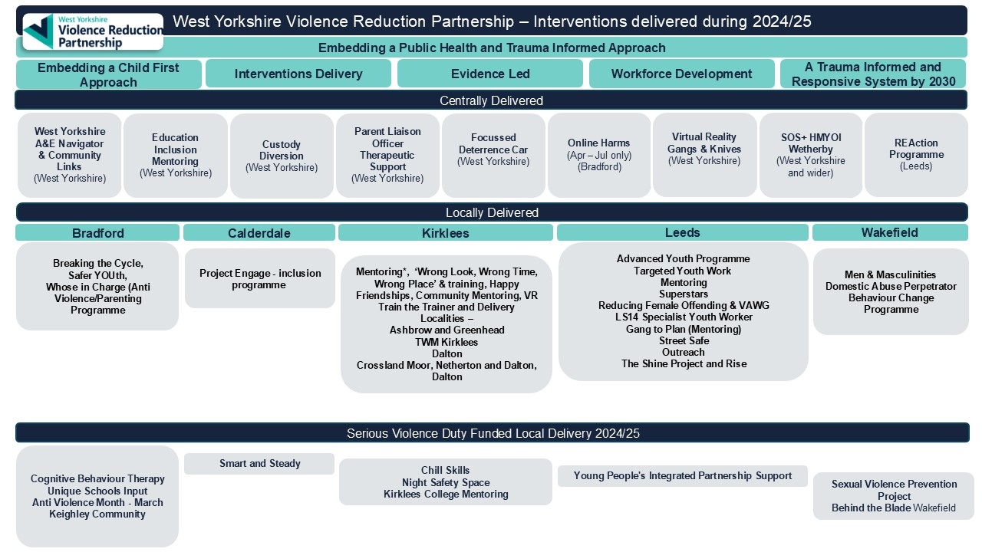
Appendix A

