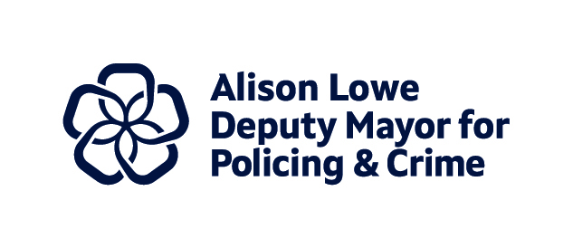
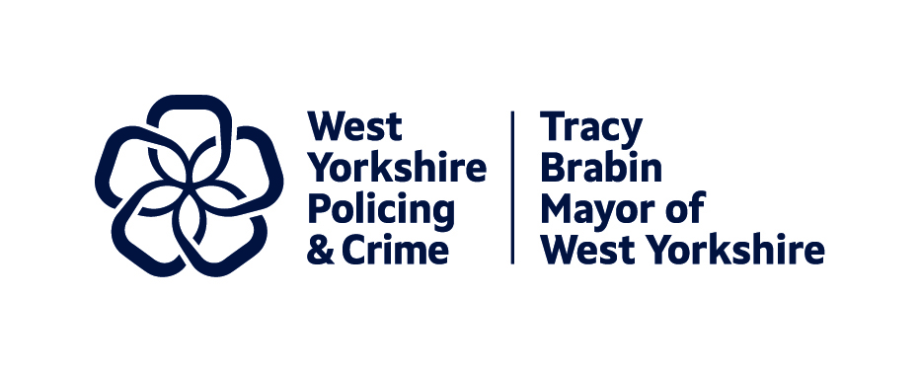

Report to: | Police and Crime Panel
Date: | 07 March 2025
Subject: | Police and Crime Plan Performance Measures – an overview
Report of: | Tracy Brabin, Mayor of West Yorkshire
Author: | Wendy Stevens – Research and Performance Manager

- Purpose of the report

  - The below overview should be considered alongside the Performance Matrix which gives the detail for the individual measures of the Police and Crime Plan.

- Theme One – Serious Violence

  - Knife crime continues to be a stubborn problem, not just for West Yorkshire but for the whole of the country. After the reductions in 2020 (due to the pandemic) the numbers have been steady and the comparison with 2019 shows our area as the second best in the MSG for decrease, but in order to reach the ambitions of the new government, this will have to change dramatically.
  - The scale of the challenge can be seen in the percentages of crime which are knife enabled, including not just robberies, but also serious assault offences.
  - The public agree that Knife Crime is a serious problem, and one way to see a significant change is to understand the causes of violence and how to deal with these. The Serious Violence Duty consultation shows the links between what the public feel are the causes of violence and what should be done – with similar themes appearing such as visible police presence, youth services and support services and activities for young people. This consultation will form part of the new Serious Violence Strategy for West Yorkshire which will look to drive improvements in this area.
- Theme Two – Confidence and Satisfaction

  - After a period of decline, confidence has been rising in West Yorkshire and rather than this being linked to perception that the police are doing a great job, this seems to be linked to positive treatment by the police and particularly that they can be relied on when needed. This is also shown in the calls for service data, where we see that over 85% of emergencies were attended in less than 15 minutes. The trend continues when looking at Victim Satisfaction data which is also rising, and one of the highest satisfaction areas is the treatment by police, but also the ability of the call taker and the ability of CSI – which all points to great victim engagement.
  - One of the lower areas of confidence is with regard to agreement that the police understand local concerns, but this falls even further when linking the police to local council actions to prevent ASB and Crime. Some of the confidence measures for Local Authority driven perception are shown, but West Yorkshire would benefit from understanding this at local level as the only data currently available is at Force level. The new ‘Your views’ survey which is about to be commissioned will help with this understanding going forward.
- Theme Three – Crime and ASB

  - Total Crime is currently falling, but we see this pattern across all of the forces in our most similar group - which points to the recording changes rather than something the force is doing. Neighbourhood Crime is not dropping in the same way, so this indicates that the areas where crime is affected by recording changes is sat elsewhere. Although Neighbourhood crime is below 2019 levels, overall numbers have not changed much since the start of 2023/24.
  - The crime types which are reducing can be seen as those which have been linked to ASB with public order offences and harassment offences falling. Although these crime types are falling, public perception of ASB is that it is increasing.
  - In the September data an extra chart was included in the ONS download of public perception data. This shows the % of people who feel that ASB is a big problem in their area
  - 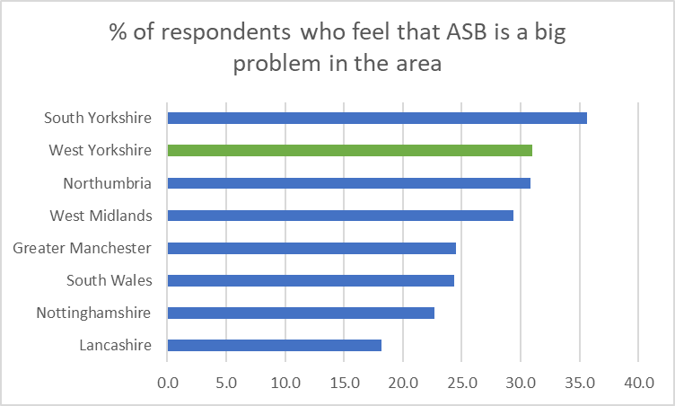
  - We can see that in our MSG we are second highest with only South Yorkshire above. This seems to correlate with the responses to the Police and Crime Plan where ASB was highlighted as the main area of concern for the residents of West Yorkshire.
  - In the Needs Assessment we noted that Neighbourhood Crime seemed to be linked to deprivation, and the indices of deprivation show that for many we are below England and YatH average. The VRP have shown how this is linked to Serious Violence and this should also be considered as part of the picture for Anti-social behaviour. Again, the local data will help us to understand this further and why there is a discrepancy between perception of ASB and crime/incident figures.
  - The below highlights the Mayor’s work to combat the negative indices of deprivation around the labour market
  - West Yorkshire Combined Authority – Economy projects
- Theme Four – Supporting Victims and Vulnerable People

  - West Yorkshire has seen a decrease in overall VAWG offences due to the decrease in the Stalking and Harassment category – as discussed in total crime, much of this is due to recording changes. Hate Crime is also on the decrease, but this could also be due to recording changes. The increases in Rape and Sexual Offences continues – and although the assumption is that this is positive (these are under-reported crime types) this is still to be evidenced.
  - The number of incidents linked to Mental Health episodes was on a long-term decline, but recent increases seem to have levelled, and the lower number of missing incidents continues.
  - This is despite West Yorkshire having a higher percentage of looked after children (per referral) and those on Child Protection Plans, although the numbers classed as Children in Need is lower than the national average.
  - Overall West Yorkshire has lower than average progress for Drug treatment services, but higher than average progress for alcohol services, but this is being looked at by local processes linked into the West Yorkshire Combatting Drugs Partnership.
- Theme Five - Investigations
  - The increase in positive outcomes for Rape continues with the emphasis in this area by the Women’s Safety Unit. One area of concern is the outcomes for Domestic Abuse and recent national figures show that West Yorkshire is struggling in the area. Positive action is being taken by both West Yorkshire Police and the LCJB and we look to this improving in the near future.
  - Some of the protective order numbers are starting to show increase, but not yet back to the numbers seen before. This is being tracked through the PEEL updates which includes these and other orders.
  - The LCJB national updates were paused but are now available on the website. The next iteration of this document should give an overview of the changes here.
- Theme Six – Equality, Diversity and Inclusion

  - Stop and Search and Use of Force were discussed in detail at the recent Community Outcome Meeting and some of the measures are shown here. Although the number of Stop and Searches having a positive outcome have increased, this is still disproportionate with regard to black and ethnic minorities, so is being considered as part of the actions of the Police Race Action Plan
  - The satisfaction gap is currently increasing, after a period of lower figures. The low gap for the Force Crime Management Unit is an exemplar in this area.
  - The number of Ethnic Minorities at senior levels shows promise, but the lower numbers at Inspector level may be a concern going forward. We await the new Equality Duty Measures being published and will report when possible.
- Theme Seven – Vision Zero Measures

  - Vision Zero high level measures are showing good decreasing trends, but some of the data sets are not currently available and will be built up as part of iterations of this document.
  - Some other data linked to Vision Zero is reported on including the numbers of drink drivers stopped over the festive period. These all feed into the picture of the fatal 6 in West Yorkshire.
  - Appendix 1 – P&CP – Performance Framework.
CONTACT INFORMATION

Contact Officer: | Wendy Stevens – Research and Performance Manager
E-mail: | wendy.stevens@westyorks-ca.gov.uk

