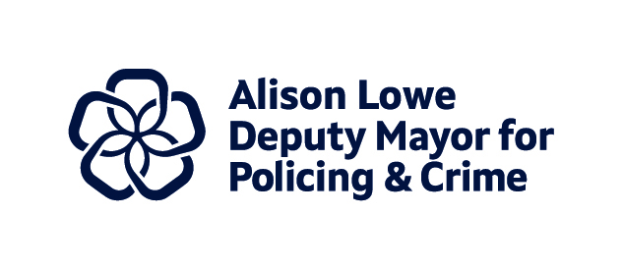
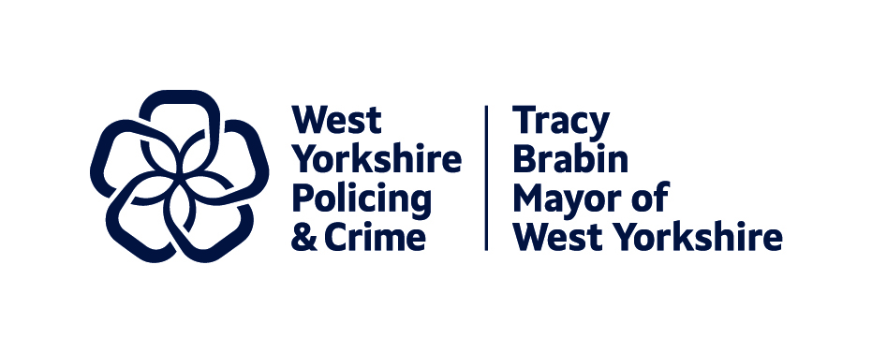
Item 7 Appendix 1

Report to: | Police and Crime Panel
Date: | 13th September 2024
Subject: | Policing Landscape for the new Police and Crime Plan
Report of: | Alison Lowe – Deputy Mayor for Policing and Crime
Author: | Wendy Stevens – Research and Performance Manager

- PURPOSE OF THE REPORT
  - Since the inception of the last Police and Crime Plan there have been some fundamental changes in the policing landscape which affect the new Plan and the priorities in it.
  - This report’s purpose is to highlight some of those changes and give a brief overview to Panel members of the different elements to be considered, and the current thinking regarding these.

- BACKGROUND AND CONTEXT
  - The Police Reform and Social Responsibility Act 2011 sets out the requirement for the Mayor to issue a Police and Crime Plan as soon as practicable after taking office and, in any case, before the end of the financial year (31 March) in which the Mayor is elected.
  - The Plan is important as it sets out and communicates the policing and crime priorities, as the Mayor sees them, to West Yorkshire Police; the public; partner agencies; the Police and Crime Panel; the Home Secretary; and others with an interest in how West Yorkshire is policed and kept safe.
  - In writing the new Police and Crime Plan, the Mayor will take into consideration the current policing landscape. As this is the second term of the West Yorkshire Mayor, some of the priorities from the first Plan will continue, as well as looking to where these can be improved to better reflect the current picture in West Yorkshire.

- STRATEGIC PRIORITIES
  - To decide the policing priorities for West Yorkshire, the Mayor undertakes widespread consultation with the public of West Yorkshire including communities, partners and other stakeholders.
  - Alongside this consultation, there is a comprehensive Needs Assessment which sets the context of West Yorkshire in terms of policing and crime challenges.
  - It is from these two pieces of work that the strategic priorities for the Plan will be decided. The following information forms part of the consideration in the Needs Assessment.

- PROGRESS

Current Policing Landscape
    - When looking at the Performance Measures in the new Police and Crime Plan, there are a number of national considerations that need to be made. The following section looks at these and how they affect the Police and Crime Plan.

Government and Local Priorities

Since the last Police and Crime Plan there has been an increase in government intervention at local level.

Previously the Police Service had worked to targets set by central government, but this changed when there was a reflection that targets often produced unintended consequences, with numbers chased rather than understanding what was best for the local area. This led to a period where priorities were driven at local level. More recently the government (of the time) started looking at national priorities and how these could be driven locally.

This began with the formation of Violence Reduction Units following a government priority document looking at Serious Violence Crime (due to the increases in knife homicides): the Serious Violence Strategy.

This was in 2018 before the first Mayoral election in West Yorkshire. Soon after there followed the end-to-end rape review (published in 2021: see here).

This review promised progress reports and scorecards looking at the convictions for rape and their progress through the criminal justice system. This brought about the Local Criminal Justice Board (LCJB) delivery dashboards. There are two data sets, one for all crime and another to look at rape offences only.

The Tackling Violence Against Women and Girls (VAWG) Strategy was created as a result of this review: Government VAWG Strategy. This followed a public survey where there was a call for evidence, and this brought about the new National Policing Lead for Violence Against Women and Girls (VAWG) and the start of the National Police Chief’s Council (NPCC) work in this area.

In July 2021 the Beating Crime Plan was published and this introduced the National Policing Priorities. This is a set of performance measures (specifically not targets) which each force is mandated to report on. From this came the amendment to the Policing Protocol Order (see here for the associated guidance: Guidance for the Policing Protocol Order Amendment) which puts into statute how the local policing body (i.e. Police and Crime Commissioners [PCCs] and Mayors with PCC powers) should report on the National Policing Priorities in a transparent way.

These National Policing Priorities brought about the formation of new performance boards for policing.

National Boards

To oversee the performance against the national policing performance measures, a number of boards were set up.

The National Policing Board (NPB) was chaired by the Home Secretary, and it was established to enable the Home Secretary to directly engage with the policing sector to set the long-term strategic direction for policing.

Membership of the NPB ensured the views of leaders in the policing sector were represented, to establish consensus and commitment to agreed priorities. The chair of the Association of Police and Crime Commissioners (APCC) had a permanent place on the board and additional PCCs attended to support specific agenda items.

For more information on this Board please see here.

This Board has not met since January 2024, and we await the decision of the new government about this Board.
  - Legislation
    - As with the hiatus around the national boards, there is uncertainty around specific pieces of legislation that impact our work. Whilst the Mayoral elections were taking place, we were looking at a number of legislative pieces that would affect policing and crime, but the general election stopped some of these, with only one main piece making it through the washup before the election.
    - One piece of legislation was enacted at the end of 2023, and this was the Online Safety Act. This Act was to provide more safety for online users. It places specific obligations upon various online services with Ofcom being tasked with enforcement.
Key measures from the Online Safety Act include:
- Social media platforms are required to remove illegal content quickly or prevent it from appearing, including content promoting self-harm.
- Social media platforms are expected to prevent children from accessing harmful and age-inappropriate content.
- New laws to tackle VAWG were introduced.
- The biggest social media platforms have to stop users being exposed to dangerous fraudulent adverts.
It was felt that this legislation could help the police force to tackle challenges around several issues (e.g. online child sexual abuse, fraud, and VAWG) by working with big technology companies to help expose criminals.
Several new offences were introduced in the Act including cyberflashing, encouraging or assisting self-harm, and sharing or threatening to share an intimate photograph or film.
Recent events, such as the use of social media to promote extremist views, has prompted further debate about the extent of the Act.
- The Victims and Prisoners Act was passed before the general election. It has had several parts enacted, which include:
- Putting the principles of the Victims’ Code on a statutory footing.
- Introducing a statutory duty on PCCs, local authorities and health bodies to collaborate when commissioning support services.
- Defining Independent Sexual Violence Advisor (ISVA) and Independent Domestic Violence Advocate (IDVA) roles.
- Requiring the Victims’ Commissioner to lay their annual report before Parliament.
- Updating the definition of a victim.
We will hear more about this going forward, as many of the parts to be enacted will have a significant impact for Policing and Crime. The Act places significant additional responsibilities on PCCs (or, in our case, the Mayor) to monitor the compliance of all agencies with the Code.
There are a suggested 21 compliance measures, measured in three ways; metrics, Victim’s Feedback (though a new national survey), and Process Narratives (internal process review and management).
Also, the duty to collaborate is introducing a different approach to commissioning that will require further cooperation between the different statutory partners.
These and other parts of the Act will form parts of update papers to the Police and Crime Panel as they are enacted.
    - One Bill that was halted was the Criminal Justice Bill. This looked at:
- Compelling attendance at sentencing.
- Harsher sentences for violent and sexual crime.
- The expansion of police powers such as searches of premises suspected of containing stolen goods without a warrant.
- Allowing for prisoners detained in English and Welsh prisons to be transferred to foreign prisons.
This will be part of the consideration of the new government as to what should be taken forward. This is part of current consultation.
  - PEEL and Special Measures
    - The inspections by the HMICFRS (His Majesty’s Inspectorate of Constabulary, Fire and Rescue Services) are continuing.
    - PEEL (Police Effectiveness, Efficiency, Legitimacy) continues to be the main inspection by HMICFRS and is currently on a rolling programme to take in all forces between 2023 and 2025.
    - In July 2024, the last inspection from this rolling programme was published for West Yorkshire. This forms part of a more substantive paper to Panel. However, the substantial amount of data that HMICFRS collects to produce these assessments means there have been several changes to how they operate, which will affect policing.
    - The first of these is the single set of data that HMICFRS provide for the National Crime and Policing Measures, as discussed earlier.
    - HMICFRS produce the Digital Crime Performance Pack for PCC’s and forces to provide a single set of data on the National Crime and Policing Measures. There is a public version of this data available on the HMICFRS website currently, but the decision was made to not update this in the future.
    - This single set of data is then used to provide an early warning system. The early warning system identifies positive and negative force outliers with respect to performance against homicide, serious violence and neighbourhood crime. The methods for identifying outliers were developed by the Home Office in collaboration with the NPCC, HMICFRS, the College of Policing and the APCC
    - The early warning system has three main objectives:
- Provide insight on performance: The early warning system should provide PCC’s and forces with insight on how the force is performing compared to others. This insight helps forces to choose how they address any performance issues and adopt best practice.
- Formalise provision for support: This will formalise the criteria for flagging outliers and establish the roles that policing partners have in providing support to poor performance forces.
- Establish a process to understand performance: This should create a process to improve the National Policing Board’s understanding of best practice and common performance issues. It should encourage collaboration between the national leads.
    - The outlier data feeds into the PEEL assessment, and this now forms part of the monitoring stage of the inspection. Previously, the monitoring only took place during the PEEL assessment, but now there are two parts to this:
- Scan: The default phase of monitoring, the scanning phase uses data and information from a range of sources to highlight poor or deteriorating performance and identify potential areas of concern.
- Engage: If a service is not responding to a cause of concern, or if it is not succeeding in managing, mitigating or eradicating the cause of concern, it is probable it will be moved to the Engage phase. The service may receive support from external organisations such as the APCC and the College of Policing during this time.
    - More information can be found here including the list of forces that are currently in the engage part of the monitoring, or that have previously been in engage.
    - Currently, West Yorkshire Police is the largest force in England and Wales that has not been under engage monitoring.
  - Code of Ethics
    - The College of Policing has developed a statutory Code of Practice to complement a non-statutory Code of Ethics (or Ethical Policing Principles).
    - The Ethical Policing Principles are as follows:

    - For more information, please see Ethical policing principles | College of Policing
    - This new statutory Code of Practice sets out the actions that Chief Officers should carry out to ensure that they promote and support ethical and professional behaviour within their forces.
    - Chief Officers should:
- lead and take action to ensure ethical and professional behaviour,
- take action to ensure that unprofessional behaviour is challenged,
- take action to ensure that staff welfare is understood and managed,
- have a duty to ensure openness and candour,
- take action to ensure continual professional development,
- and take action to respond to misconduct.
    - This includes:
- Developing and conducting an annual assessment of threats to public confidence and legitimacy.
- Working effectively with their PCC or equivalent to agree local complaints and misconduct arrangements.
  - West Yorkshire Police’s Strategy
    - The West Yorkshire Police - Operational Policing Strategy 2023 – 2028 was launched in September 2023 and is an update on the 2020 Policing Strategy.
    - It sets out the strategic direction for West Yorkshire Police over the next five years to deliver their part of the Mayor’s Police and Crime Plan.
    - The full Plan on a Page can be viewed at the end of this report.
    - The vision is the same as the Police and Crime Plan.
    - The three Policing Purposes remain unchanged.
  - Strategic Policing Requirement
    - Section 77 of the Police Reform and Social Responsibility Act 2011 enabled the Home Secretary to issue the Strategic Policing Requirement (SPR) document, and the first publication was released in 2012. With this document, the Home Secretary fulfils their statutory duty to set out the national threats (the definition of which can be found in the glossary) at the time of publication and the appropriate national policing capabilities required to counter these threats.

The SPR requires PCCs to have regard to the document when issuing or amending their Police and Crime Plans and to provide an assurance statement within Annual Reports, explaining how they have had regard to the SPR and the influence it has had on the strategic direction of the force and the objectives for the year.

These national threats are defined as follows:
- Violence against women and girls
Definition: The SPR makes use of the definition provided by the Home Office in the July 2021 strategy document titled Tackling Violence Against Women and Girls. According to this definition, acts of abuse or violence against women and girls are those that disproportionately affect them. Whilst the definition is titled “violence against women and girls," it covers all genders and victims of any of these offences.
- Terrorism
Definition: The SPR classifies Terrorism as using or threatening serious violence, causing significant harm to individuals or property, endangering lives of not just the perpetrator, posing a serious risk to public health or safety, and the interfering or disruption of electronic systems. The intent is to influence the Government, intimidate the public, or advance political, ideological, racial, or religious causes.
- Serious and organised crime
Definition: Serious and Organised Crime (SOC) refers to the deliberate preparation, coordination, and execution of serious offences by individuals, groups, or transnational networks.
The focus is on the following three main themes: Drugs, Fraud, and Organised Immigration Crime (OIC).
- A national cyber incident
Definition: A national cyber incident refers to a cyber-attack that targets any of the thirteen sectors within the Critical National Infrastructure (CNI), encompassing areas such as chemicals, civil nuclear, communications, defence, emergency services, energy, finance, food, government, health, space, transport, and water.
- Child sexual abuse
Definition: Child sexual abuse refers to pressuring or persuading a child or young person to engage in sexual activities, which do not always involve extreme violence or an awareness from the child of what is happening. Technology can be used to enable offline sexual abuse as well as online sexual abuse. Male adults are not the only perpetrators, sexual abuse can also be committed by women and by other children.
The SPR breaks this down into three categories:
- Assault by penetration: rape or oral sex.
- Non-penetrative acts: masturbation, kissing, rubbing, and touching outside of clothing.
- Non-Contact activities: such as involving children in looking at, or in the production of, sexual images, watching sexual activities, encouraging children to behave in sexually inappropriate ways, or grooming a child in preparation for abuse.
- Public disorder
Definition: Public disorder refers to a situation in which a group of people engage in violent or disorderly behaviour that endangers public safety, order, or peace. The SPR notes that there are numerous critical limits where events or incidents within society will lead to these behaviours, including controversial or fatal deaths involving the community or the police, increasing inter-community tensions.
These behaviours include but are not limited to localised events such as rioting, looting, vandalism, violence, and arson. It is important to note that the SPR clarifies that lawful protests are not considered a form of disorder and are protected under the right to protest peacefully, but they are at risk of being hijacked by those intent on causing public disorder.
- Civil emergencies
Definition: The SPR uses the Cabinet Office definition, which refers to an event or situation that poses a significant threat and risk to human wellbeing to individuals residing in the UK, to the environment of a place in the UK, or to the security of the UK.
Events or situations include war, natural hazards, severe weather, flooding, human and animal disease, major industrial or transport accidents, and terrorist or cyber security incidents.

- GOVERNANCE
  - The above topics are discussed regularly with West Yorkshire Police to understand the current position and to look at how this is affecting policing in West Yorkshire.
  - Many of the items also affect our office, so we have recently instigated a horizon scanning bulletin which keeps a check on these types of issues and ensures that the Policing and Crime officers are up to date with current topics.

- AIMS AND FUTURE DELIVERY
  - As discussed previously, this understanding will form part of the new Police and Crime Plan for West Yorkshire, and the measures in the new Plan will track areas that require it.
  - Understanding the current policing landscape only forms part of the picture for the Police and Crime Plan, but ensures national issues are held in focus for the priorities.

- EQUALITY, DIVERSITY AND INCLUSION BENEFITS AND IMPLICATIONS
  - Equality, Diversity and Inclusion (EDI) implications are considered at all points and a full Equality Impact Assessment has been undertaken for the Police and Crime Plan to ensure that EDI principles are embedded as the Plan is written.

- IMPLICATIONS FOR YOUNG PEOPLE IN WEST YORKSHIRE
8.1 There are a number of potential implications for young people in West Yorkshire. These are being considered as a cross-cutting theme for the next Police and Crime Plan, alongside keeping a Child First lens on all we do.

- FINANCIAL IMPLICATIONS
  - None

- LEGAL IMPLICATIONS
  - Police Reform and Social Responsibility Act 2011 sets out the requirement for the Mayor to issue a Police and Crime Plan as soon as practicable after taking office and, in any case, before the end of the financial year (31 March) in which the Mayor is elected.
  - The Police and Crime Plan should determine, direct and communicate the Mayor’s priorities for their local area during their period in office, including:
- the Mayor’s police and crime objectives for the area;
- the policing of the police area which the Chief Constable is to provide;
- the financial and other resources which the Mayor is to provide to the Chief Constable;
- the means by which the Chief Constable will report to the Mayor on the provision of policing;
- the means by which the Chief Constable’s performance in providing policing will be measured;
- the services which the Mayor is to provide or arrange to support crime and disorder reduction, or help victims or witnesses of crime and anti-social behaviour;
- and, any grants which the Mayor is to make, and conditions (if any) of those grants.
  - The objectives of the Police and Crime Plan and the actions that underpin them should be informed by:
- a comprehensive understanding of local needs and resources,
- based on local performance data;
- officer, staff and stakeholder consultation;
- and financial information, amongst other resources.
  - The objectives outlined in a Police and Crime Plan should also be informed by:
- the elected manifesto which sets out the Mayor’s pledge to the people and communities they serve;
- the Strategic Policing Requirement (SPR) – it is a statutory requirement to include this in the Police and Crime Plan. The SPR is issued by the Secretary of State periodically, and sets out current national threats (e.g. terrorism, civil emergencies, threats to public order, Serious and Organised Crime (SOC), large-scale cyber incidents, child sexual exploitation etc) and the national policing capabilities required to counter them.
- priorities of the local police force;
- and priorities of other partner agencies and other stakeholders.
  - In developing the plan, the PCC has a statutory duty to consult:
- the Chief Constable;
- and local people and victims of crime.

- EXTERNAL CONSULTATION
  - As discussed, the Police and Crime Plan will be informed by an extensive consultation process.
  - The results of this consultation will be reported in the Voice of West Yorkshire document and published alongside the Police and Crime Plan.

- RECOMMENDATIONS
  - That the Police and Crime Panel note the report and feedback any comments to inform the development of the new Police and Crime Plan.

CONTACT INFORMATION
Contact Officer: | Wendy Stevens
E-mail: | Wendy.Stevens@westyorks-ca.gov.uk

Supplementary information: West Yorkshire Police’s Plan on a Page:

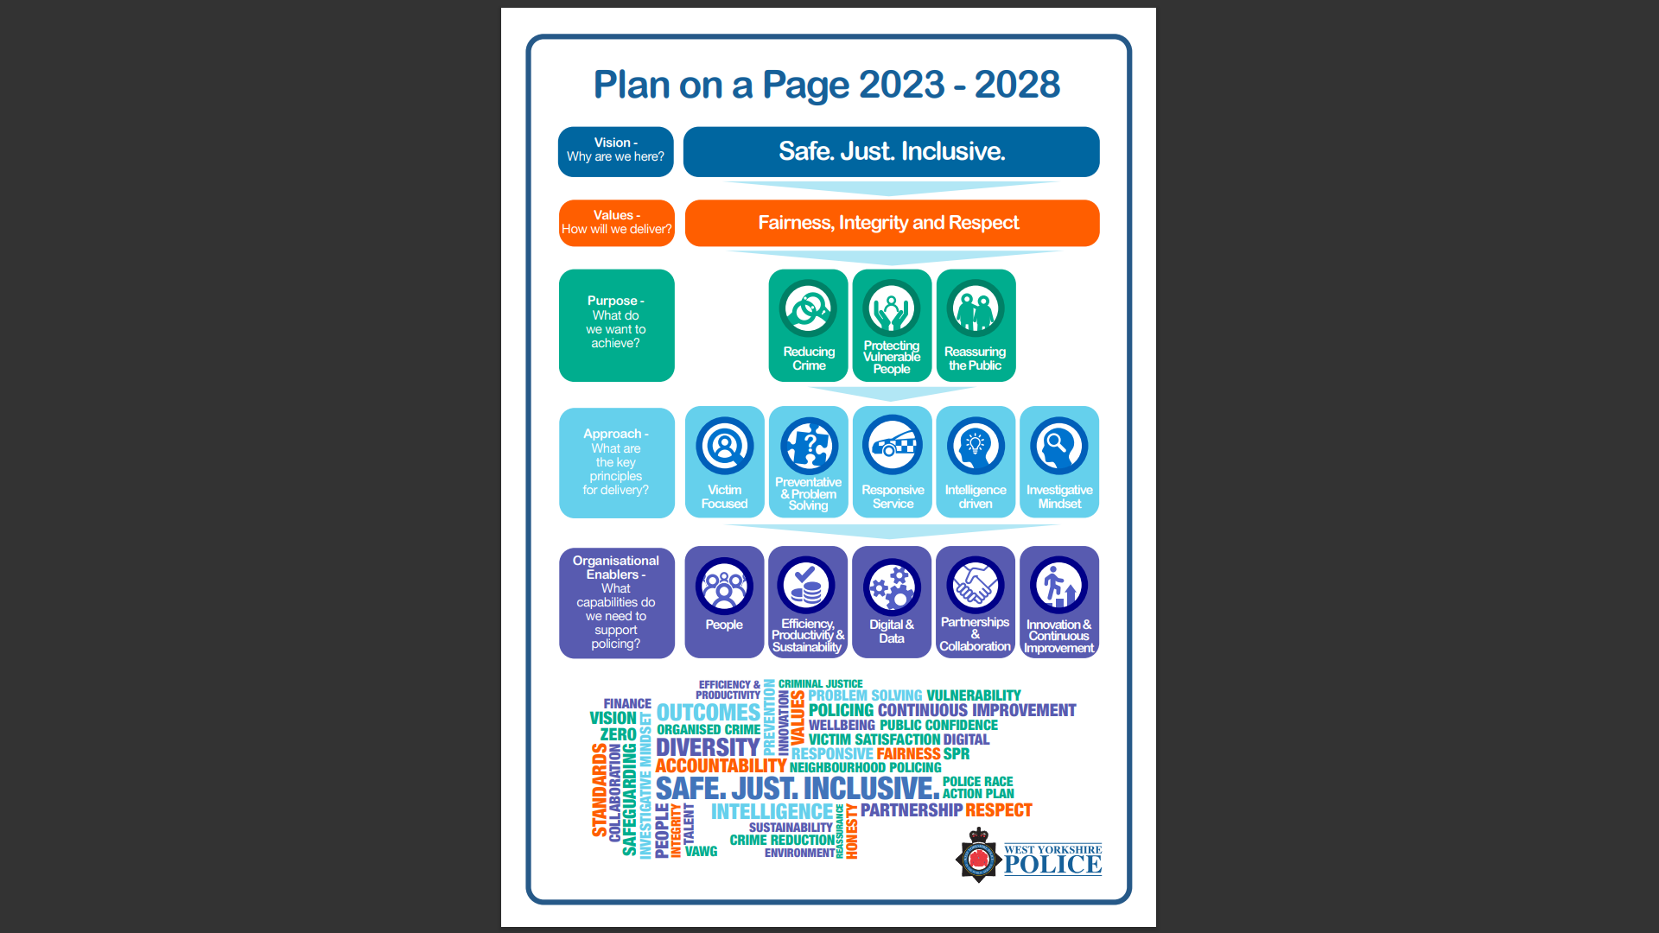

Child First Approach - West Yorkshire Combined Authority (westyorks-ca.gov.uk)

